**Mr Tomlinson leaves the school after 25 years and the boarders leave after 67.....!**

**( Remember to check the top of the home-page to see if there have been any recent additions to this section.)**

**In 1960 a new school stage was completed, at the 'field end' of the gymnasium making large scale productions far easier to organise. It was officially opened in May of that year.**

**Also in 1960, the 'Old Sexonian' magazine brings the sad news of the death of Lawrence Abram, the school's second headmaster. Mr Abram had been headmaster at the school for sixteen years.**

**The early 60's saw decisions being made regarding a swimming pool for the school and in the July of 1962 a fete was held which raised over £300 towards the school fund.**

**Bruce Purvis has very kindly sent in a number of pictures relating to  1962/63 and the fete in question. It actually took place on July 21st, 1962.**

**The army cadets were invited and put on a variety of displays -**

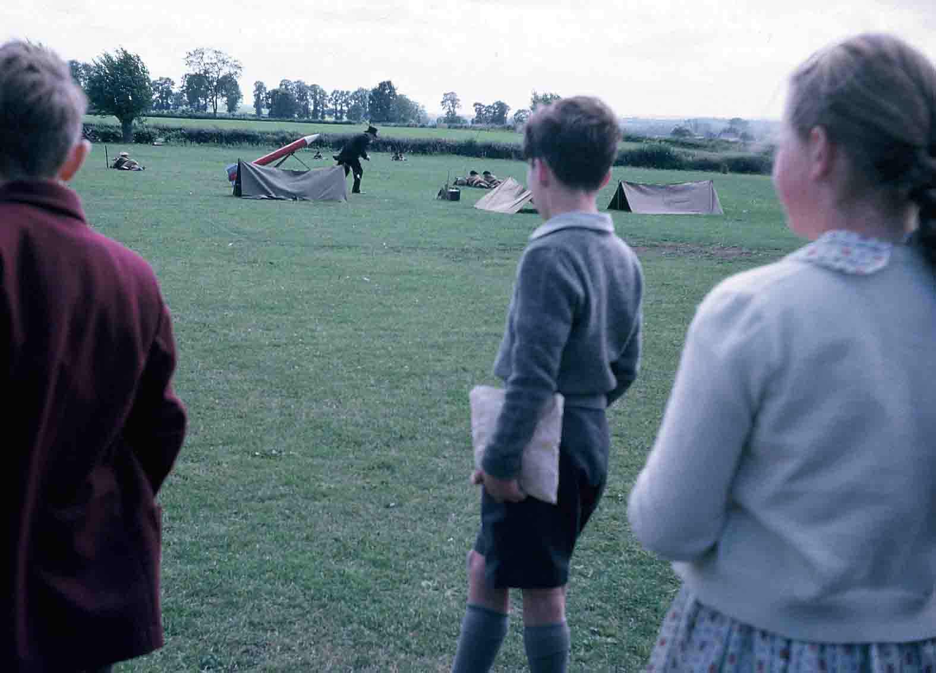  
**(I'm not sure what the figure in the top hat and tails got up to, or how mobile the red rocket was - perhaps someone can remember and let me know. - MJ)**

**In this picture, the cadets line up for inspection after the ' battle '.**

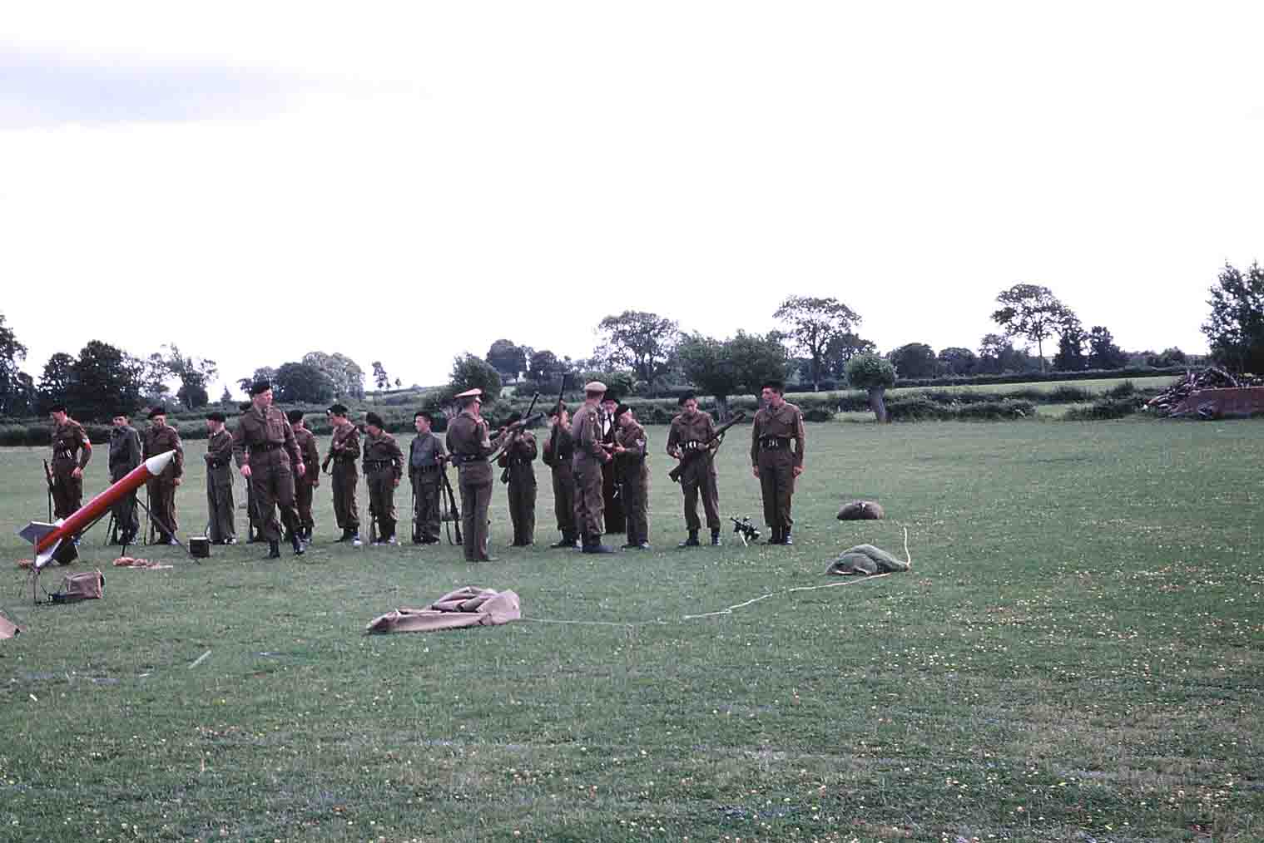

**Morris dancers also strutted their stuff -**

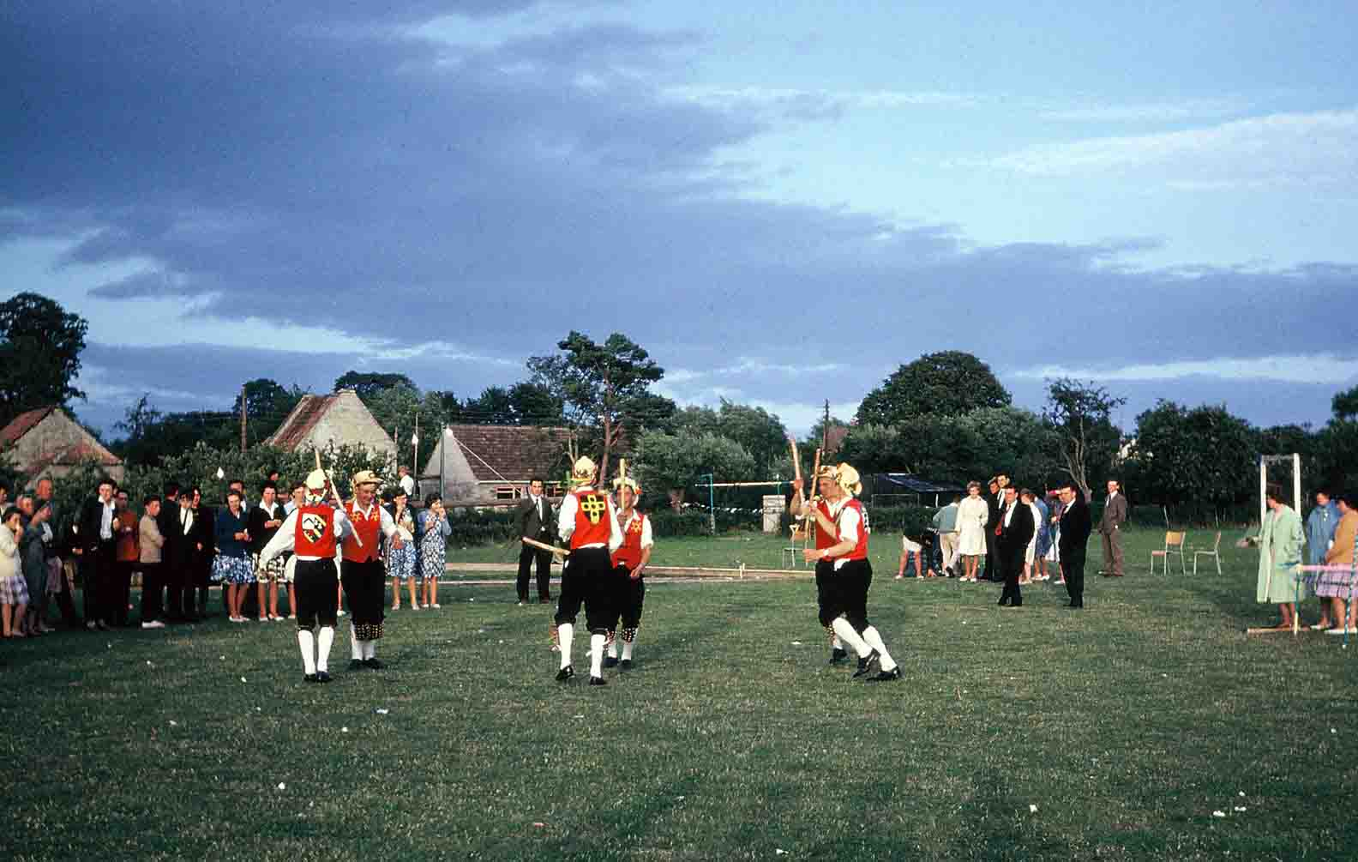

**(This scene is behind the goal of the seniors football pitch.)**

**One of the many, money making stalls was the inevitable skittle alley. Here we can see James Ross having a go and I *think* that's Pete Lee in the background. In front of Pete Lee can be seen John Woodword and Tim Wellington (head bowed) - 2nd left in the picture is Bobby Brooks. Michael Cooke thinks that Stephen Hughes is beside Bob Brooks and that the lad on the far right is Adrian Lloyd.**

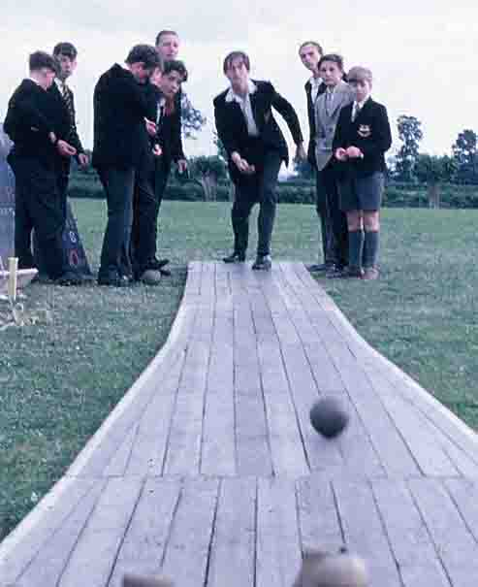

**The greasy pole was a popular stall, I'm sure!  Here, Bruce Purvis, (left), takes on Paul Lawton - I wonder who won ?**

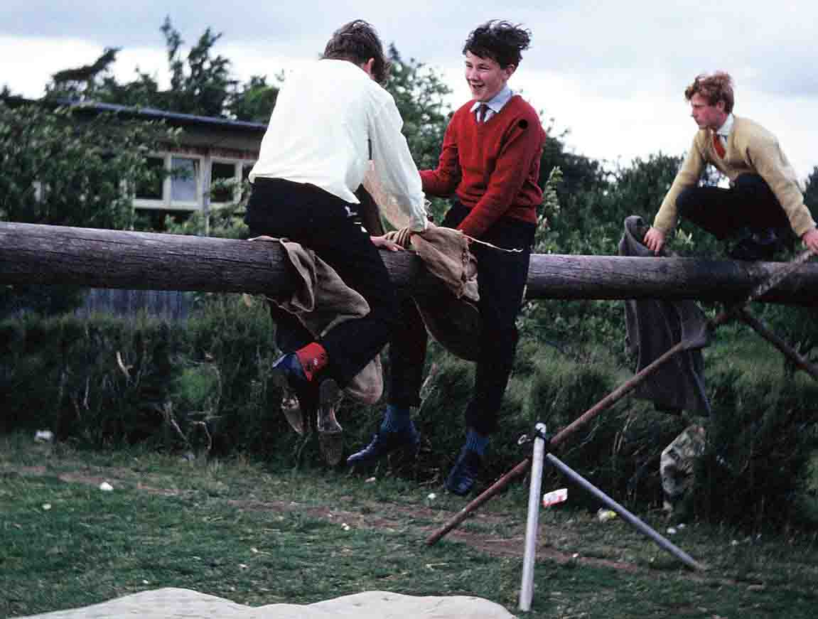

**A year later, almost to the day (24/7/63), the school held its annual Sports day on the field. This would have been a Blake v Somerville affair. The photos aren't of the sporting action, however, but of some of characters who were out on the field at the time.**

**Here we can see Peter 'Jim' Phillips in a far corner of the field, complete with cigarette, although the only actual smoking I can see going on is the old tree stump smouldering in the background! - some of Hubert Fisher's handiwork?**

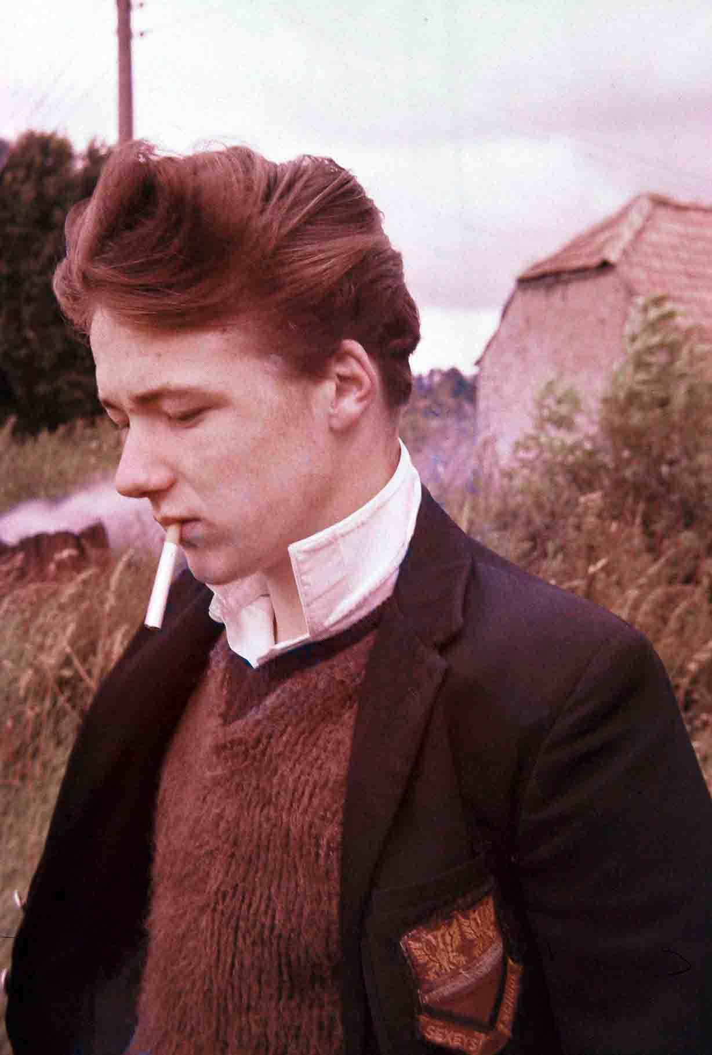

**Also out on the field, was Les Pavey, the woodwork teacher. ( I hope he didn't run in to Peter Phillips!)  Behind Les you can see the high jump event . Looking at the height of the bar, it was probably the 1st years having a go!**

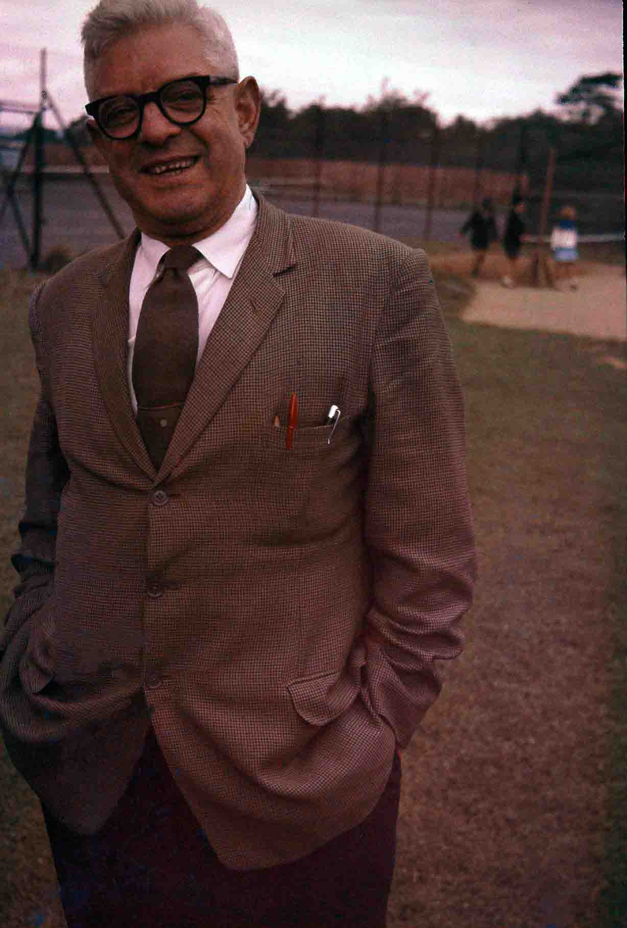

Miss Janice Goode, the geography mistress, also attracted the attention of the camera that day. Her hood up, suggests that it wasn't the warmest of summer days, though**.**

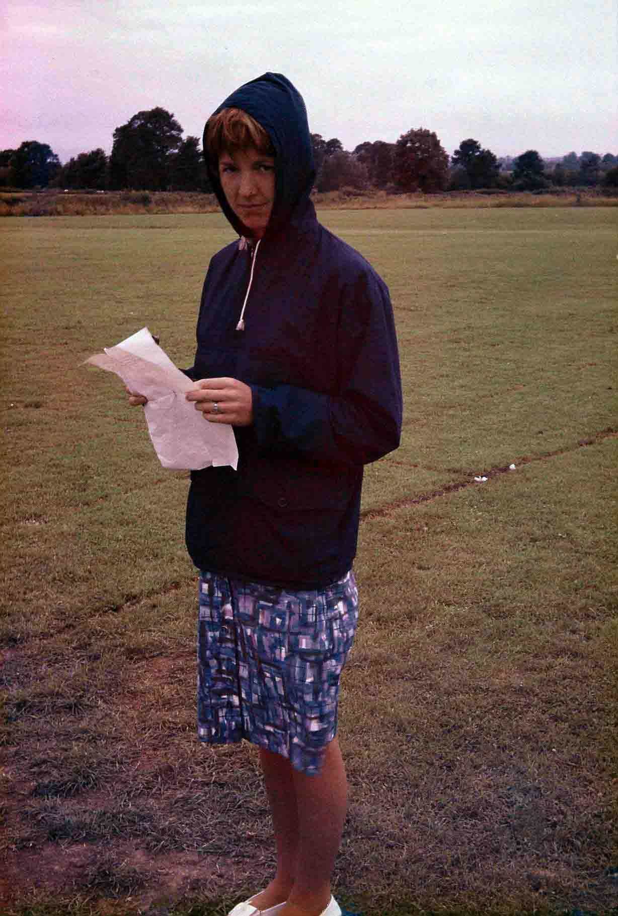

**The following day, on Thursday the 25th of July, the inter- house cricket match took place.**

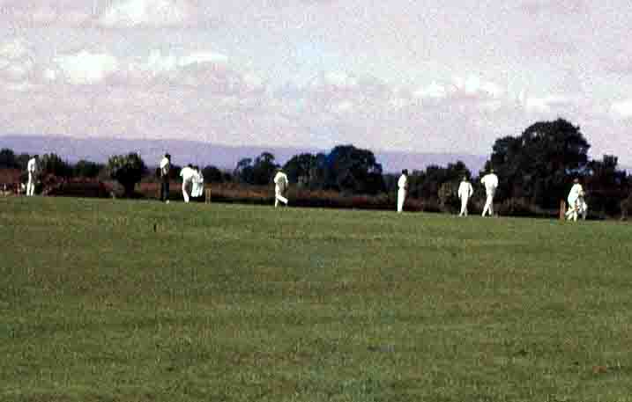

**(Does anyone know the result of the match, that year? - MJ)**

**Bruce was also able to supply me with photos of two of the school's stage productions of the early '60's. These were 'The Pirates of Penzance' and 'The Gondoliers'. 'Pirates' was to be the very first production on the new stage.**

**Terry Stirzaker sent in this picture of the whole cast -**

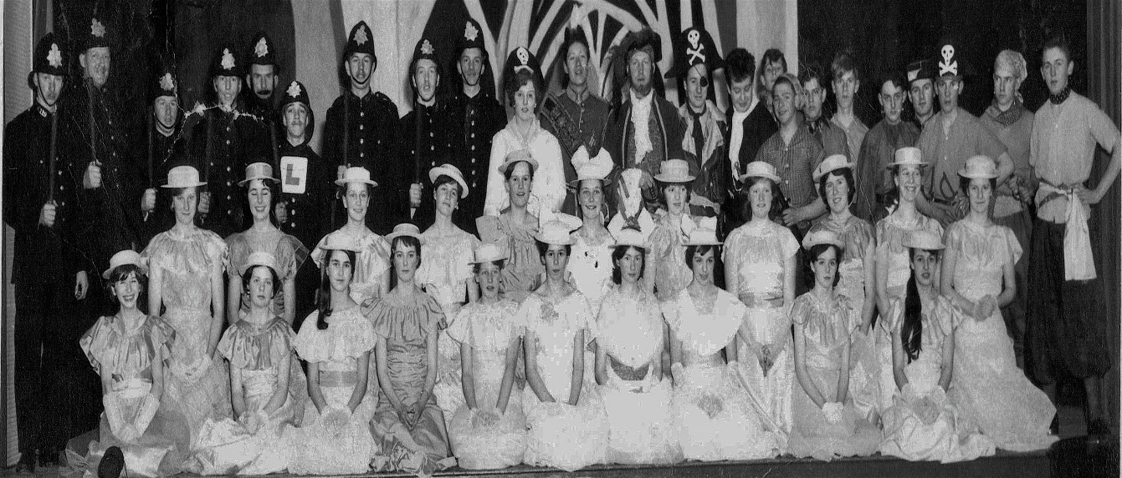

Back Row L-R: Terry Stirzaker ~ Mr Roberts ~ Ian Wilder ~ Michael Bryne ~ Mr Moore ~ John Woodward ~ Robert Hector ~ Robert Ford ~ Basil Carter ~ Angela Wilshire ~ Robin Mitchell ~ Mr Lee ~ Roger Ashman ~ Graham Badman ~ Michael Hill ~ Roger Hooper ~

Philip Binning ~ Peter Gregory ~ Roy Tripp ~ Mr Churchyard ~ Richard Wiggs ~ Bruce Purvis ~ Ian Hart.

Second Row L-R: Jennifer Chew ~ Jennifer Streeter ~ Susan Dudley ~ Audrey Croker ~ Susan Dean ~ Veronica Gibson ~ Pamela Tyley ~ Christina Lloyd ~ Jennifer Marsh ~ Anita Seal ~ Yvonne Rawlinson

Front Row L-R: Patricia Ham ~ Bronwen Hughes ~ Elizabeth Rose ~ Christine Peck ~ Jennifer Belcher ~ Sheila English~ Susan Brookes ~ Deirdre Studley ~ Kirstie Buchanan ~ Hilary Freckingham. (Thanks to John Grant for the updated cast list).

T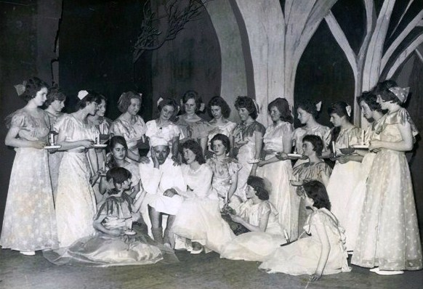 The Chapel scene showing Major General Stanley with his many daughters. (Liz McDonnell - nee Rose)

Back Row (Standing) L-R: Jennifer Streeter ~ Jennifer Chew ~ Audrey Croker ~ Susan Dudley ~ Anita Seal ~ Veronica Gibson ~ Susan Dean ~ Sheila English ~ Jennifer Marsh ~ Christina Lloyd ~ Yvonne Rawlinson ~ Hilary Freckingham ~ Deirdre Studley ~ Pamela Tyley.

Front Row (Kneeling & sitting) L-R: Patricia Ham ~ Elizabeth Rose ~ Robin Mitchell ~ Susan Brookes ~ Bronwen Hughes ~ Jennifer Belcher ~ Christine Peck ~ Kirstie Buchanan.(Thanks to John Grant for the names).  **A newspaper article of the production can be seen in Gallery 8, picture 1.**

**According to the 1963 'Old Sexonian' magazine - ' On three successive evenings the cast played to a full audience, and was very well received. The orchestra provided excellent accompaniment and was conducted by Mr Tonkin. The general effect of the scenery (a modernistic interpretation) and costumes was complemented by the musical director. In short, the production was very successful and received good reports in the local newspapers.'**

**( Do you have any particular memories of taking part in this production? - If so , send them in! - MJ)**

**'The Gondoliers' was performed on three nights in 1964, March 12/14th.**

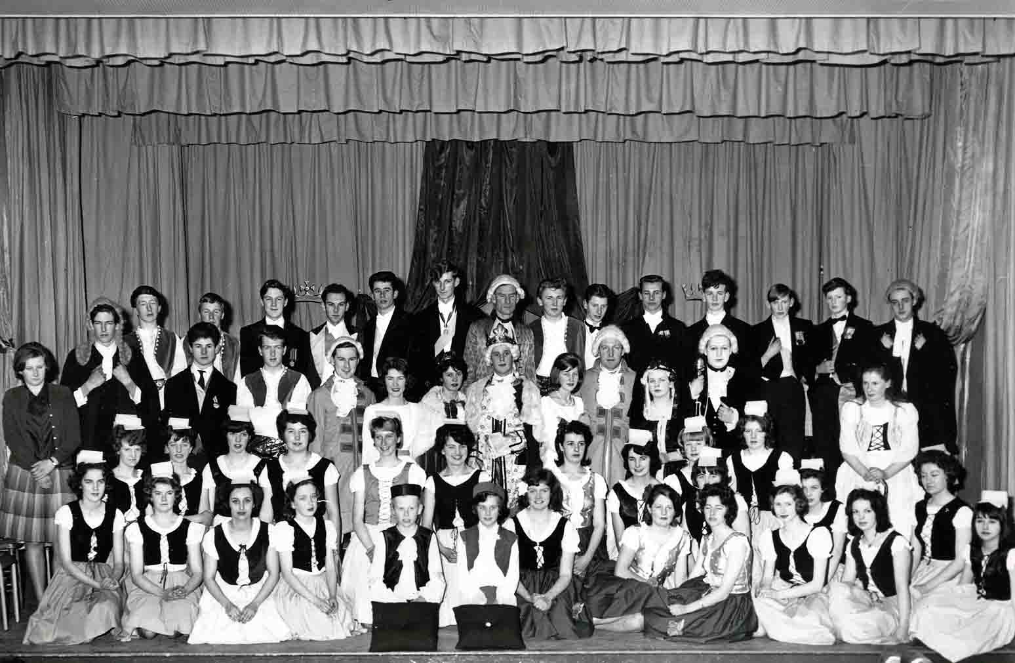

**Name Legend**

**Back Row (14 faces) L-R: Robert Salway ~ Ian Wilder ~ Paul Lawton ~ Mike Cooke ~ Clive Watts ~John Sheldon ~ Mr Glyn Moore ~ Ian Hart ~Terry Stirzacker ~ Colin Thorne ~ Stephen Hughes ~ Richard Overy ~ Michael Farley ~ Roy Tripp. Third Row (13 faces) L-R: Jennifer Chew (not in costume) ~ Peter Baker ~ John Roberts ~ Bob Ford ~ Mr Gordon Churchyard ~ Susan Brookes ~ Sheila English ~ Michael Hill ~ Jennifer Belcher ~ Mr Peter Lee ~ Bronwyn Hughes ~ Graham Badman ~ Sally Cole.Kneeling upright (13 faces) L-R: Lynette Fry ~ Sally Heal ~ Susan Viney ~ Thelma Owen ~ Myrtle Litten ~  Jennifer Carter ~ Hilary Freckingham ~ Jennifer Streeter ~ Judy Grantley-Smith ~ Alana Ward ~ Pamela Tyley ~ Lynn Thomas ~ Helen Boswell. Kneeling/sitting (12 faces) L-R: Josephine Ford ~ Joy Heal ~ Mlle Colette Loustau (French Assistant) ~ Rachel Salway ~ Kerrigan Litten ~ Gillian Hughes ~ Christina Lloyd ~ Jenny Bradley ~ Audrey Croker ~ Pat Ham ~ Elaine Plimsoll ~ Jane Streeter.(Alice Maskrey, Deirdre Studley, Yvonne Rawlinson, Kirstie Buchanan and Stephanie Marshall are also included in the programme, but are apparently not in the photo. (Update by John Grant)**

**Many, many thanks for all the info/pictures you've sent in, Bruce - MJ**

**(Once again, if anyone can help get rid of the dreaded ?s, please send the names to me - MJ)**

**Joy Berckmans joined Sexey's on 3rd June 1964 when her parents returned to the UK from The Netherlands to live at Axbridge. She was sixteen years old and all of her previous schooling had been in Dutch schools; so she spoke and understood very little English. Here is her story.**

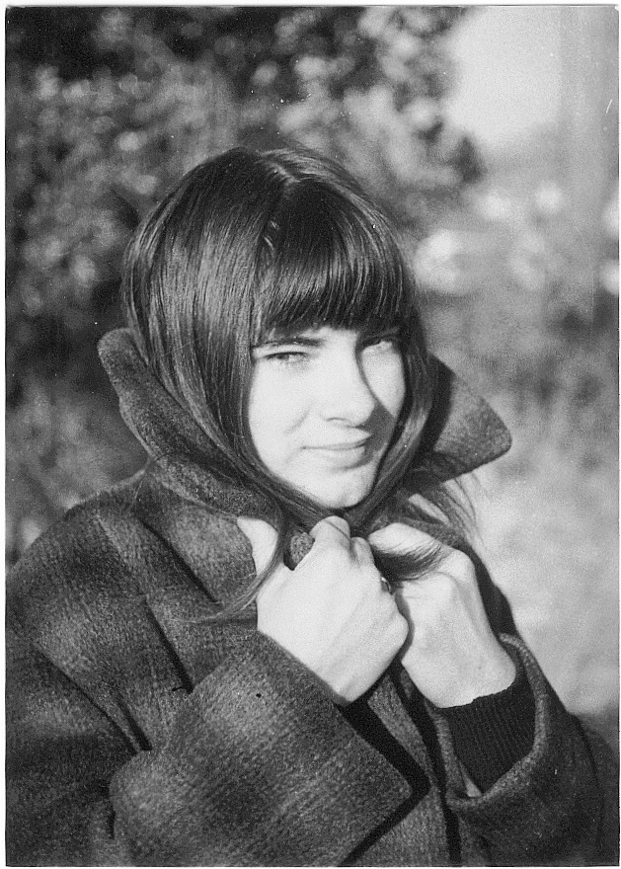

**"My name was Joy Berckmans and, even though I was born in Somerset, I was brought up in The Netherlands. We moved from Holland to Axbridge 6 weeks before my O Levels in Holland were due in April 1964. Not a kind thing to do to your daughter. In Holland I had been top of the class in English, but when I came to live here, I couldn't understand a word anybody was saying. Everyone spoke too quickly and Somerset English is a very different language to what I had learnt at school. I started at Sexey's in June 1964 and then started school properly in September. I was put back to the beginning of the 5thyear (all my classmates were a year younger than me) and preparation for 'O' Levels started in earnest. My English still wasn't very good and I had no motivation to learn it, as all I wanted to do was to go back home to Holland.**

**Here are my impressions of Sexey's. School uniform doesn't exist in Holland, so I didn't like that a lot. Seeing teachers with their black cloaks was like stepping back in history. The school itself was very old fashioned compared to what I was used to, but the pupils all made me feel very welcome. At the time I suppose I must have been quite a novelty being the only foreigner in the class. The teachers couldn't do enough for me, but the language problem caused me a lot of distress. In quite a few lessons they gave me books to read, but by the time I had struggled translating a page, word for word, I'd more or less forgotten what I'd read. So, geography, history and English were big problems to me; however, all the teachers were very patient with me. In French I used to translate from English to Dutch and then to French and vice versa, which also caused me a lot of extra work. Mr Packer was arranging for me to take a Dutch O level examination, which was very good of him, but as my English was not that special, I probably would have failed it. In December I eloped with my Dutch boyfriend to Gretna Green, but we were picked up after four days by my Dad and his friend, so we never got married. It was also the end of my schooling. I was very unhappy living in Axbridge, but my short time at Sexey's was reasonably happy and the teachers couldn't have done more for me."**

**(I traced and contacted Joy in March 2017 and she was pleased to talk to me about her brief stay at Sexey's. Joy eventually married and had two children. She still lives at Axbridge and now speaks very good English, with a West Country accent, having lived here for over 50 years. She is still friendly with some of the Old Sexonian girls she travelled to and from school with on the School Brake. I reflected on how challenging most of us found some subjects and how much more difficult they would have been if we had not been able to speak English. Joy seems to have been expected to achieve the impossible. Gretna Green seems a bit drastic, but running away would seem quite a reasonable option.)**

**John K. Grant    (Many thanks for sharing your interesting story with us, Joy!  MJ)**

**In 1964 Brian Breese joined the school as head of the Geography and PE departments. Here are Brian's memories in his own words (the email was originally sent to John Grant) -**

**'Hi Mr Grant! Congratulations on your detective work and, even moreso, on the great and fascinating work you've been doing, along with Martyn 'Bunt' (to me he was Bunter!) James on the Old Sexonians website! Sexey's was my first teaching post having completed my Post-Graduate Diploma in PE and Teaching Cert. at Loughborough in 1964 . These along with my Cambridge Geography degree, allowed me to head the Geography and PE department at Sexey's until 1967 when I sailed from Southampton on a banana boat (it took 10 days) to fulfil similar positions in a 3-year teaching contract at Rusea's High School in a small town called Lucea some 25 miles west of Montego Bay!'**

'**To check if I really wanted to continue in Jamaica I left Rusea's at the end of my contract and spent two enjoyable but bloody cold years in Yorkshire at Wakefield Tech. - back to Jamaica (different banana boat!) - two more years at Rusea's, 3 at Little London Secondary (when I got married to Gareth's mum) and then 10 at Green Island Secondary (principal for the last 3 years). Then I left the rural areas to head for Kingston in 1987. Went in to Sports Goods as sales manager of two different companies, then Sports Officer for the Caribbean Cement Company (2nd child, new wife and a lovely daughter - Summer Breese - now embarked on a 4 year Pharmacy degree at Reading University), then 8 years as Cricket Operations Officer with the Jamaica Cricket Association. For the last 6 years I've been the Programme Director of the Courtney Walsh Foundation using cricket as a rehabilitation tool in the island's correctional centres (prisons) introducing and developing the game with all 4 Disability Groups (esp. with the Blind and Physically Disabled) and using the game to help improve the lives of youngsters in a number of Kingston's tougher communities!'**

**'Gareth, as you may know, captained Jamaica at all levels and the West Indies U19's and played one test match - after 10 years professionally with Durham ( check his end-off match at Lord's in the 2014 London Cup Final!!!). He has just embarked on his own coaching business in the same North-East, is married to a Jamaican doctor and they have given me two lovely 'grans'  - Savanna (8) and Max (3).'**

**'I really loved my stint at Sexey's but realised as a Geography teacher I needed to see some more of the world and one evening my mate Jackie Evans ( a professional footballer with Hereford FC and a teacher at Blackford Primary) & I took out an atlas and speared the World Map - my 'weapon' went into Jamaica and his into Kuwait and that's literally where we respectedly ended up! At that time I was, after the closure of the boarding house, staying at Dave Patch's ( Milkman and Wedmore CC's wicket keeper )  cottage in Wedmore.'**

**' Of the boarders I have great memories of , in addition to 'Bunter', are David Alexander, Francis Gilette, Tim and Jerry Wellington and even John Woodward among the boys and Jane Chapman and Heather ? among the girls.'**

**' I nonetheless still appreciated my 'night off' when I worked on the bar at the Sexey's Arms owned by fellow Welshman Len (Vincent?).'**

**' Great** **staff especially in the area of sport - Pete Lee and Brian Elvins; also Miss Padmore (Arran Geography Expedition), Miss Rendell, Margaret Duckett, Glyn Moore (I'm catching you up, I'm 75 next month!) & Fred Roberts.'**

**' I saw on the website something about sports 'colours' - if I was to give them over the period I served it would have to be to Cricket - Alan 'Wally' Grout. Football - Jerry Wellington and Andrew Butcher; Athletics- Pauline Andrews; All Round - Alan Vaughan and Steve Thorne - sorry 'Bunter'!! ( I'll let it go just this once - wasn't there a special colour for trying hard with the discus?!? - MJ)  Geography - Gillian Brown.'**

**' Co-incidentally the same day I got the 'Forward'( an email from John Grant - MJ)  from Gareth I was reading a letter I got from Steve Thorne in 2003 with accompanying folio on the reunion organised by Margaret James. Can I get an email for Steve as I'd love to meet Chris Gayle on his return to Somerset for the T20 'Blast' between June 1 and 17th. When I came to Kingston in 1987 Gareth and I joined Lucas CC. (home of George Headley) Gareth was 11 and Chris who lived just over the club wall was 7!!  I used to coach both of them and a couple of years ago when Chris returned to Lucas to open a cricket nursery in his name he broke down and cried when he called out my name!**

**'Anyway as they say in Jamaica - 'nuff for now'.**

**As Bob Marley would say 'One Love' to ALL Old Sexonians!  Brian Breese.**

(Great to make your acquaintance again, Brian. I guess the fact you have such good memories of the place despite having spent just 3 years there means that they were 3 very enjoyable ones - Martyn (Bunt!) A recent picture of Brian can be seen in Gallery 8.

**My own (Martyn James) school memories date from the Autumn term of 1964 and continue to be dominated by my memories as a boarder as so much went on!  
  
Actually, my *very* first memory of the place was of my mother taking me to look at the school and meeting with Mr Tomlinson, sitting on  a bench on the front lawn - it must have been in the final weeks before his retirement.**

**Going through the school's archives, this photo was a totally unexpected find!  It's a very small colour shot of my class, which I don't believe was taken professionally - all of the other early, class shots in the archives are the usual, medium sized 'Black and Whites' taken by local professionals -although some time was obviously taken to set it up.**

**It's a *very* early picture of my class. (Can anyone else in my form remember the circumstances behind this photograph or have a larger black and white version? -  My best bet is that it was someone like Mr Ravenscroft who took a quick snap with their own camera as the professional was  taking theirs, but I've certainly never seen any larger black and white versions. MJ)**

**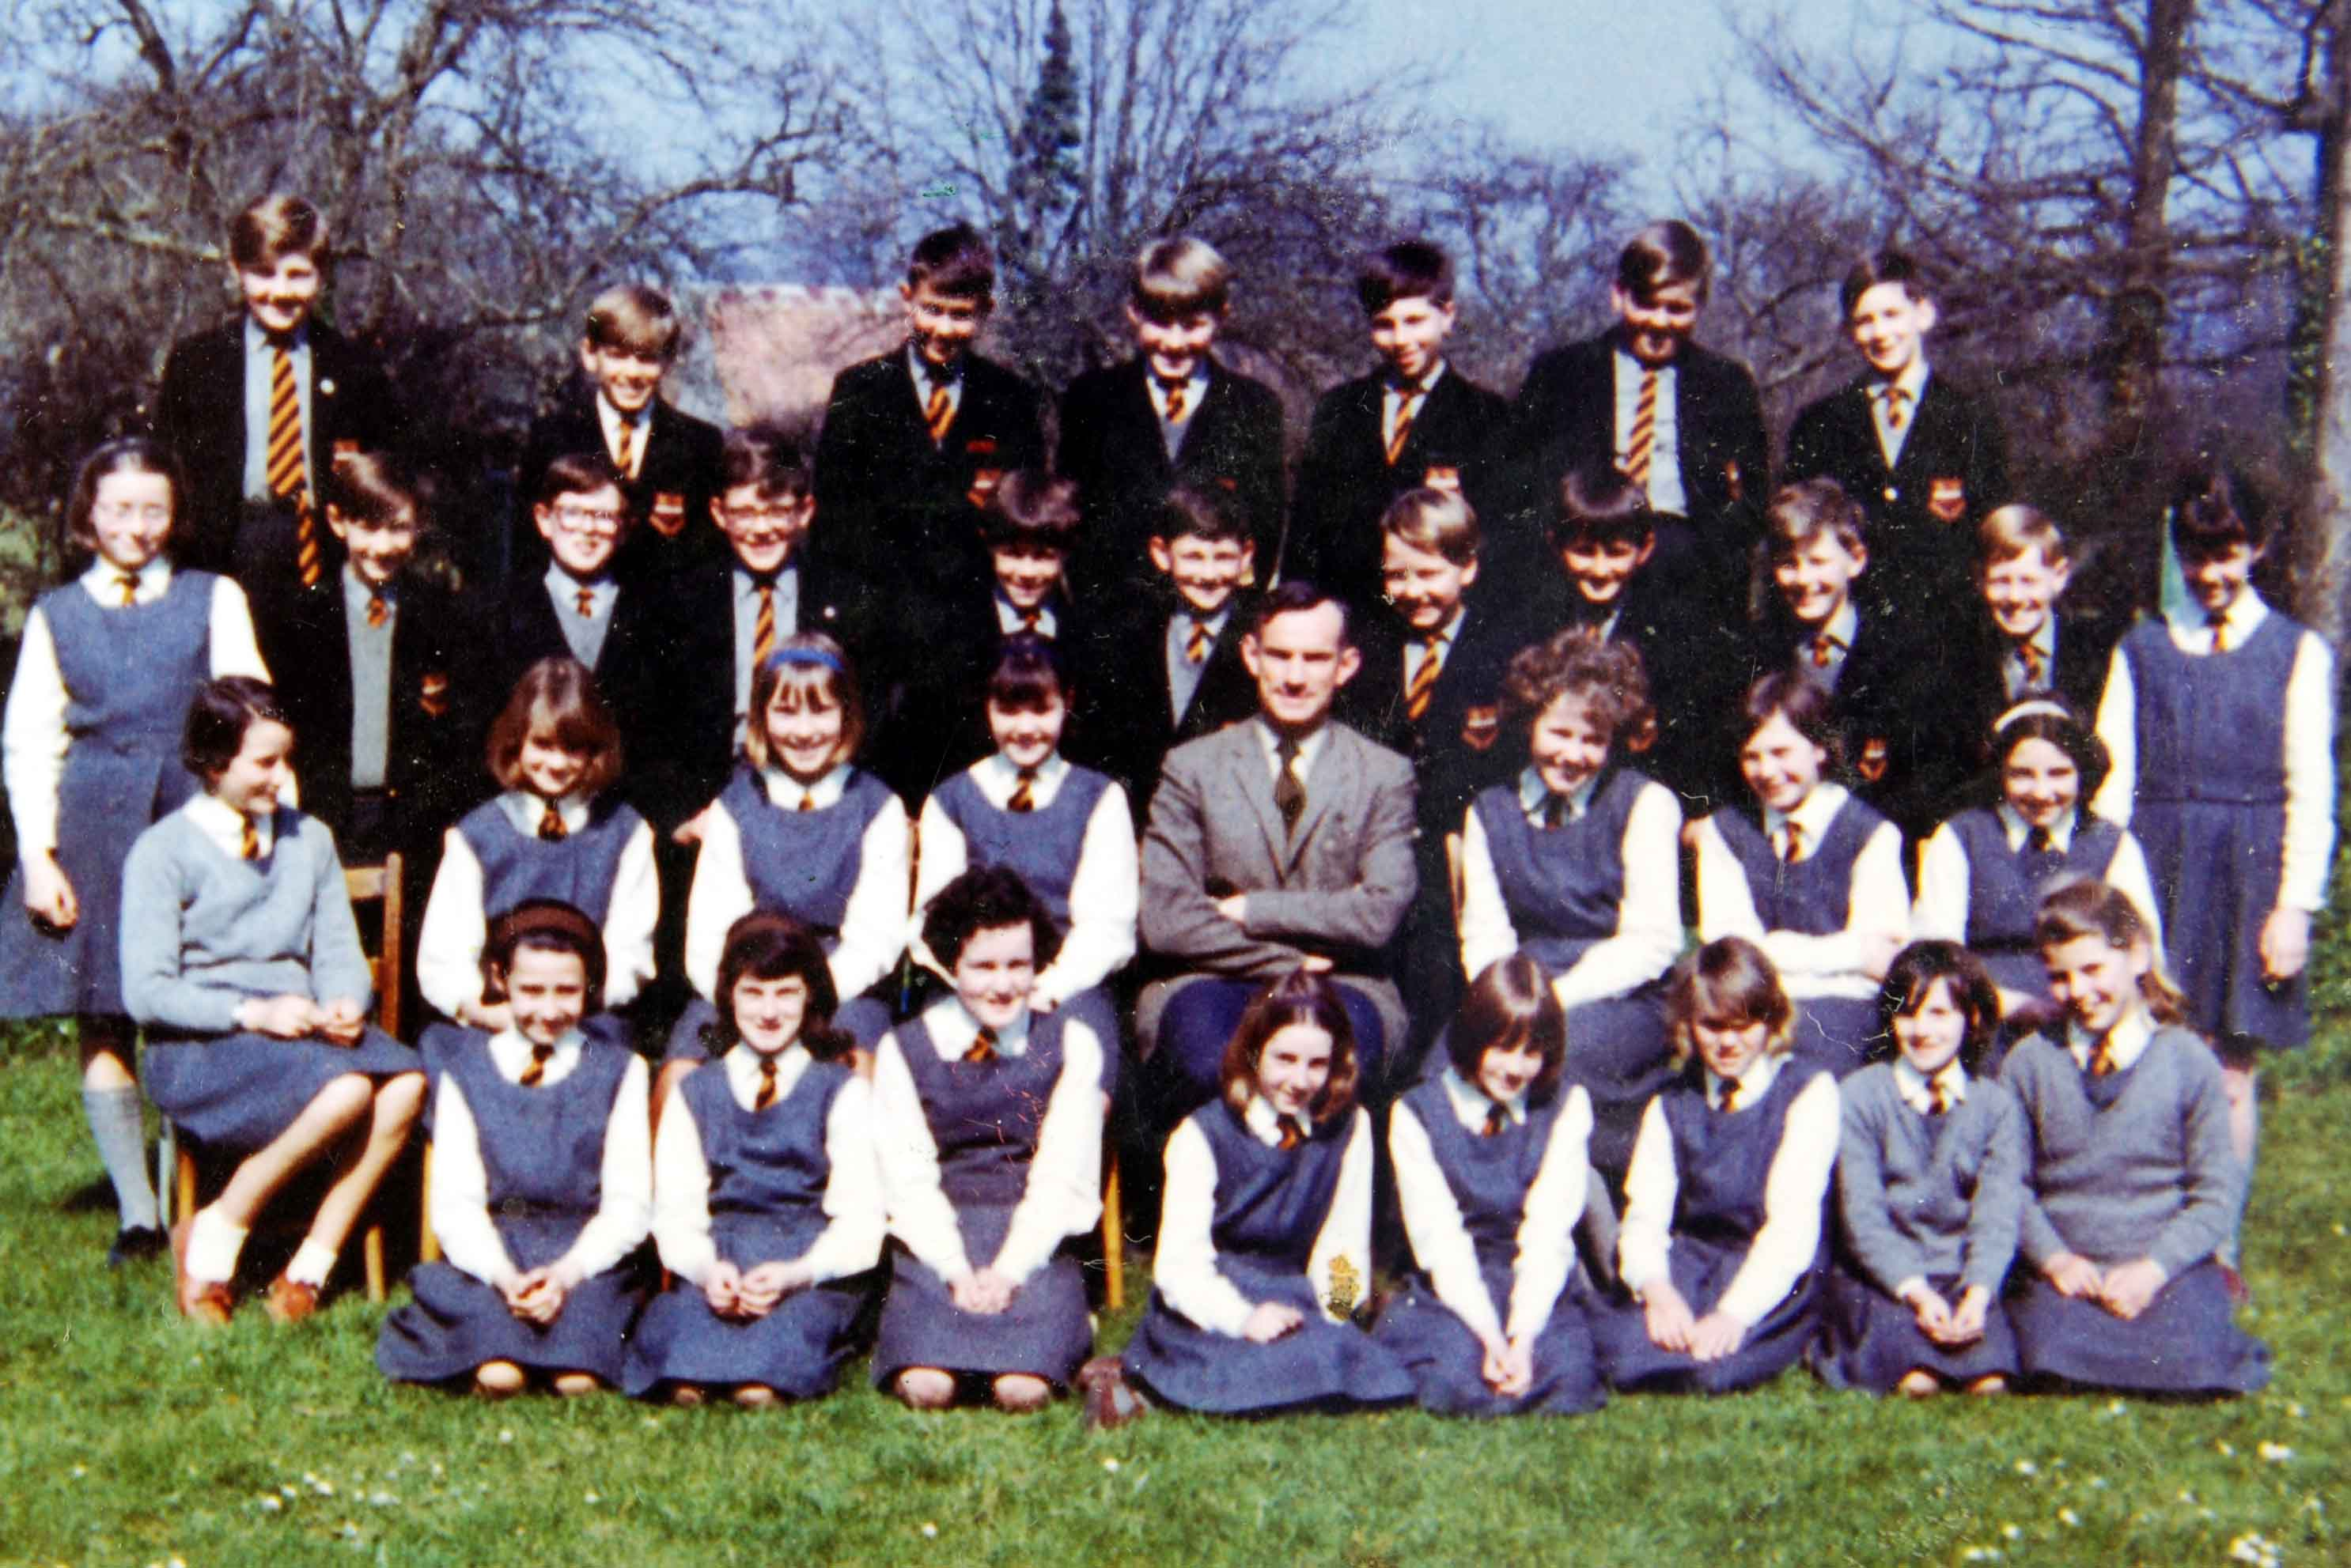  
Back Row L-R**  Phillip Ham, Francis Gillett, Ian Greer, Jon Line, Chris Carbin, John Butt, Ian Ruskin.  
**3rd Row L-R**  Margaret Chester, Andy Milne, Martyn James, Richard Sampson, David Alexander, Albert Frost, Vince Russett, Geoff Thorne, Alan Keen, David Nuttycombe, Catherine Hamblyn.  
**2nd Row L-R**  Geraldine Tracey, Jessie Emery, Christine Weir, Pam Gilling, Mr Moore, Bernice Ball, Deborah Hawkins, Anita Parker.  
**Front Row L-R**  Ann Perry, Marilyn Pitman,,Christine Hares, Janice Smith, Celia Cox, Jane Kilgannon, Linda Greenwood, Pauline Ash.  

**With regards to the school uniform, the boys wore the school blazer and tie at all times and a cap up until the end of the 2nd? year.**

**The picture shows a close up of the blazer badge (kindly loaned by Tony Cousins).**

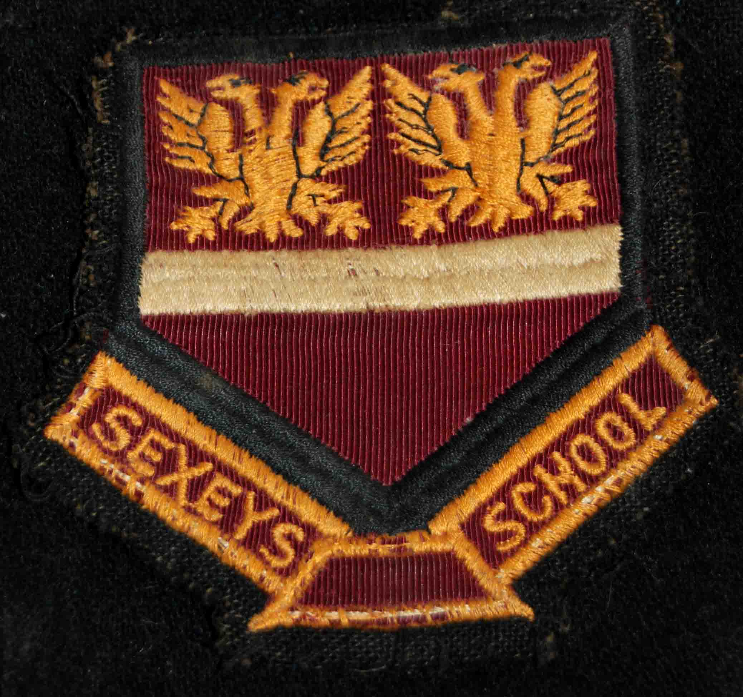

**(It's interesting that Sexey's was a *grammar* school but no attempt was made to insert the apostrophe in 'Sexey's'!)**

**The badge itself shows a pair of  eagle type creatures. Eagles were commonly used in heraldry but I'm unable to find another example of the two headed version anywhere. (More information about the design can be found in Arthur Swallow's 'History' in the 1950's section.**

**Fellow boarder, Geoff Thorne still has his cap and scarf and here they are - only the scarf still fits, though! (Thanks for these, Geoff. - MJ).**

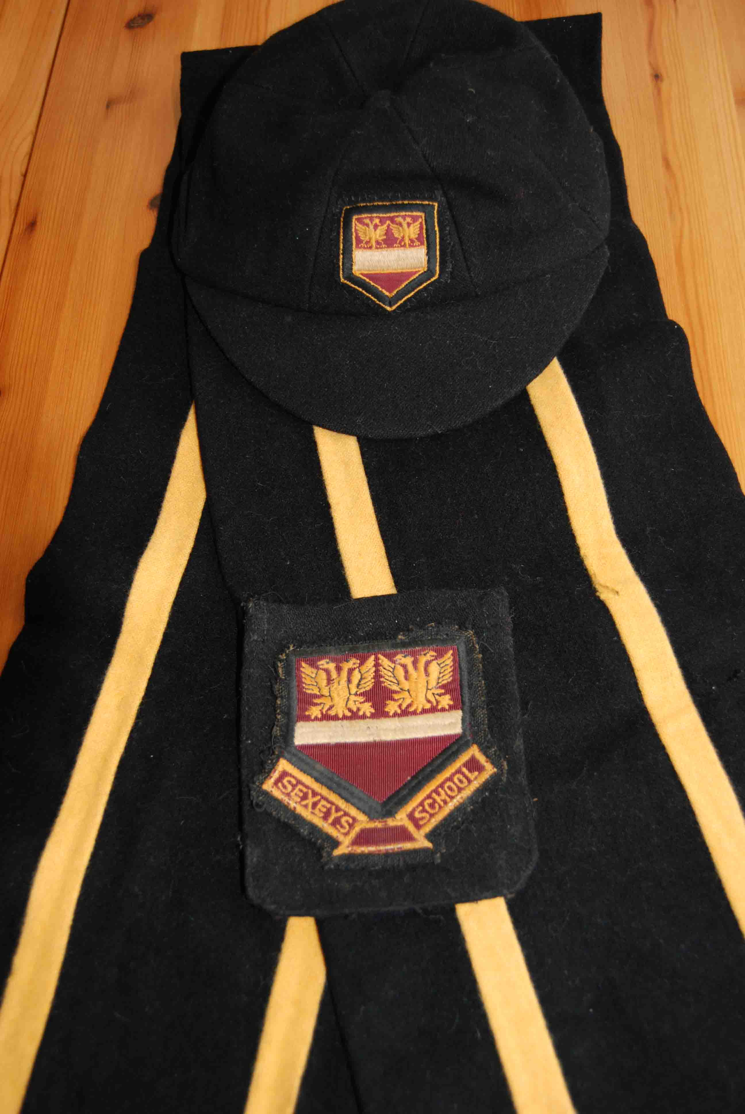

**This is the central section of the 1966, whole school picture and shows all of the school teaching staff and many of the children. At this point I was in my second year.**

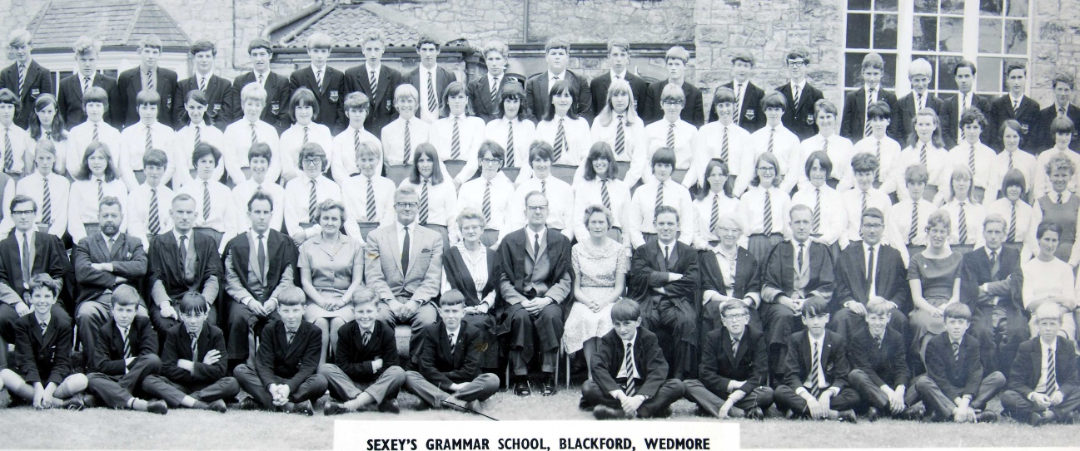

From left to right these were Gordon Churchyard, Mr Atkinson, Basil Moore, Brian Elvins, Mrs Hares(secretary), Fred Roberts, Erica Padfield, Malcolm Ravenscroft (Headmaster), Mrs Ravenscroft, Mr Brookes (Deputy Head), Isabel Rendel, Pete Lee, Brian Breeze, Beryl Leach, Ray Packer and finally, the French assistant. (I was sitting in front of 'Izzy' Rendell at the time with fellow boarder, Geoff Thorne, to my left.)  
  
**Sadly, very many of the staff are no longer with us. The only members of staff I can remember from that year who *don't*appear on the photo are Mr Hallet (Art), and Mr Swallow (Science).**

**The whole photo shows 209 pupils, so one can assume that the total number at the school in '66 would have been slightly more than this, accounting for absentees.**

**Like every other child, I had to get used to the huge changes from Primary school- moving between classrooms, different teachers, different classmates and very large 6th formers! I suppose 'us boarders' got used to the new layout more quickly than the day pupils as we were about in the school buildings until bedtime.**

**Throughout the '60's the classrooms were either in purpose-built rooms in  the old building or in wooden 'huts' on the outside, lining one edge of the school field. These wooden buildings were used for Maths, Cookery,  Biology, Chemistry and Woodwork.**

**There was also an outside Art Room - a new one was completed in January '65- my diary entry for 22/1/65 reads -  'Art in the new Art room- we were the 2nd lot to go in!'**

**My diary also reminds me that,  in June '65,  the builders were - 'getting on well with the new library', which was a very large project carried out by the builders, Maunders. Hubert Fisher, the caretaker at the time, tells me that one day he got 'roped in' to help with the construction of the building. On one occasion the concrete mixer was kept waiting a bit too long and the mix started to harden. It was a case of 'all hands to the deck' and Hubert was hurriedly enlisted to help with the laying of the floor and foundations before the mix became impossible to work with!**

**I have few memories of specific lessons but I do remember that Basil Moore, (Latin), was really funny and often injected humour into his lessons. In one lesson I remember him breaking into a silly, high pitched voice when he pretended to be the mother of Plinny - everyone just roared!**

**Fred Roberts, (Maths), could also be very amusing. I remember he used the phrase ''Percy Harris Broke His Push Bike' to help us learn sines, cosines and tangents! (the initial letter in each word represented the necessary triangle side that was required for the calculation- perpendicular, base or hypotenuse).**

**Another memory I have of one of his lessons, was when he drew a large chalk circle on the board. Instead of getting on with the lesson he took a step back and after a few seconds he picked up the large blackboard compasses.**

**After taking a few seconds to find its centre and to adjust the radius he drew another circle on top using the compasses - it was a perfect fit. He had drawn an absolutely *perfect*circle freehand! He got a well deserved round of applause from the class for that.  ( I can't remember if he used his favourite phrase, 'bless my cotton socks!' but I think there was a pretty good chance!)**

**Somehow, Fred actually got me through my 'O' level Maths - I had failed every yearly  Maths exam prior to that so I 'came good' just at the right time!**

**I actually bumped into Fred many years later in a shop in Highbridge and thanked him for performing that minor miracle.**

**Bryan Breeze, as well as being the housemaster for the boarders, taught PE and was a really nice bloke - most of the boys admired his muscular footballers legs (his calves were huge!) and most of the girls fancied him!!  Unfortunately, he left Sexey's to teach abroad (possibly due to the boarders breaking up).**

**The one time he did tell me off was when I cheated on a cross country -  I had taken, along with some other boys,  a short cut through a few hedges and someone decided to 'tell'. I remember him sitting by the cricket pavilion next to the tennis courts and stopping me (and others) as I went past. I can't remember our punishment but he was not impressed!**

**I'm sure everyone that ever did them, remembers those dreaded, cross countries really well.  We went out of the school by the hostel, down the road heading towards Blackford, turned left just before the Primary school and then across some fields and then onto a road that took us past an old, dilapidated house and then back to the school on the road leading from Heath House. I'm not sure how far they were but I couldn't do it now (even if I cheated!)**

**At the time all pupils were divided into two houses, Blake and Somerville. You had an amber sports top if you were Blake and a white one if you were in Somerville. I was in Blake but I *think* Somerville tended to have the upper hand in most of the years I was there.**

**Somehow, despite being a bit slow on the ball, I managed to get myself in the under 13's football team, playing right back.**

**My diary reminds me we were pretty hopeless (although some of the team went on to become really good players in later years) and we quite regularly lost by a 4,5 or even 6 goal margin!**

**For this photo, I remember having to stand at the back because I couldn't find my boots!**

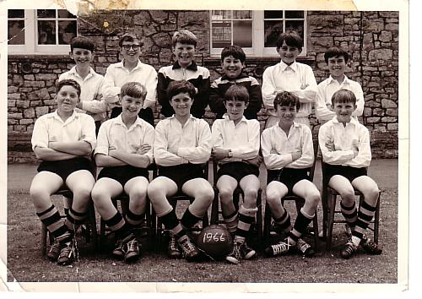

Back row ,L-R, - Albert Frost, myself, Jon Line, Colin Bateman, Geoff Thorne, Stephen Cauldron.  
Front row - Tim Ham, Phil Ham, Chris Carbin, David Alexander, Edmund? Parker , Bernard Jackson.  
 **One 'footballing' memory that does stay with me was when Robert 'Tubby' Davis broke his leg.(Robert was a boarder in the year below me.) My diary tells me it was on 18/12/65, just before we broke up for Christmas- it couldn't have been a very nice Christmas for Robert, though!**

**Robert was playing in goal at the time and he made a frantic effort to clear a ball off the goal line as the other team were attacking. Unfortunately, as well as clearing the ball, he managed to wrap his leg around the goalpost with the follow-through.**

**The result was a massive dent in his shin and his leg bent the wrong way below the knee!  Needless to say he was carted off to hospital to have the break sorted.**

**I can't remember if the match had to be abandoned but  we lost the match, an away fixture against Strode, 6-0!**

**My only other sporting achievement was throwing the discus. I was able to practise quite regularly as a boarder which led to me being quite reasonable at it and I ended up throwing for Blake. (In my later years at the school I once represented the school at the 'area' games (but with no success!)**

**One of my classmates was Ian Ruskin who has recently written to me with some of his memories -**

**Hi Martyn**

**Although I was only at Sexeys for 2 years, moving on to Brockenhurst Grammar School in Hampshire. I do have fond memories of the place.It was a scary experience at Brock, where each year had almost 200 pupils in 6 classes per year, and I really missed you lot for ages..  I eventually left school, and did an apprenticeship with the Berthon Boat Co in Lymington, building Yachts, and all sorts of boats mostly in wood. I moved to Guernsey in the mid 70s still building boats. I worked on several projects in the Uk France and Sweden, then moved into the building line, and eventually shopfitting in all sorts of places, and then office fitting.**

**I presently work for one of the biggest legal partnerships in the world**

**Mourant Ozannes. I work in the Office Services department, which means that I make sure the Photocopiers work. Which suits me fine with 5 years to go, next April.**

**I was interested to note that you taught at Berrow as my niece and nephew attended that school. Lesley and Paul Skinner, perhaps 1984 86, and just up the road from Mead Farm, where our classmate Albert Frost still lives.**

**When I read that you became good at Discus at school,I remember that my only achievement at Sexeys, other than doing 24 chimes on the Tubular Bells at the first night of Midsomer Night s Dream, instead of 12, was getting my name on the Junior Athletics Cup, by fluke, because the nearest opponent did 3 no throws in that event. I won with a pitiful throw, as I was not built for Discus, but had to do I field event. I do hope that wasnt you, Martyn. (If it was I can't remember it, Ian- MJ)**

**I was also on the trip to Giswil, but didn't enjoy it too much, as I became ill near the end, and couldn't wait to get home. I do remember the dorm in the roof of the Hotel, that was basically 2 shelves the length of the room and the trouble I got into when I swore at the teacher from Birmingham when he turned the lights on, and woke me up in the middle of the night. I just remembered I snogged Kathryn H****** in the car park. I suppose I did enjoy the trip more than I thought.**

**Don't mark this e mail too closely teach..**

**Great to catch up.. Great website... I will work on my punctuation and spelling.. Take care Bunt.. Ian   (Great to hear from you, Ian - I remember you as one of the more sporty of the boys in our class, both of us representing Blake).**

**Mid way through 1965 Ian Greer joined my class (of 64) and has recently added his memories. He writes -**

**'Hello Martyn,**

**I have found the website to be fascinating reading which has brought back many happy memories of my limited time at the school. I joined school after Easter in 1965 having just moved to Somerset from Watford when my father’s job was moved to Bristol. Although I cannot remember the circumstances, this means that our class picture shown on page 7 could not have been taken in the Autumn term of 1964. It was a big, but very welcome, change moving from a ~1000 pupil boy’s school in the home counties to a single form entry mixed country school with ~200 pupils, and a huge wrench when my father’s job moved to Cardiff and I had to leave the school at Easter in 1967. Both the staff and other members of our class were very welcoming and supportive and I quickly settled into the school. I can sympathise with Joy Berckman’s comment about the Somerset accent. Although I do not remember any difficulty in the school, I do remember listening to people talking in the doctor’s waiting room in Shipham and finding their discussions incomprehensible due to the speed. Like Mr Breese, I remember you as “Bunter”.'**

**'I do remember the class photograph being taken in 1966 and still have my copy. I have a vague memory that the school size was about 210 and I am fairly certain that it was not as much as 220 so it is likely that there are not many missing. I have strong memories of Mr Roberts teaching maths. I still make use of “Percy Harris” for my maths at work and still remember him drawing an empty parrot cage to illustrate a “Polygon” in one of the hutted class rooms. His teaching made a big difference to my life as we had finished covering the core O level maths curriculum and had started Boolean maths and covered a bit of Karnough maps and set theory before I left the school at the end of the 2nd term in the third secondary school year, so when I went to my new school I was able to pass O level maths at the end of year 4, despite the quality of the maths teaching I received there. This meant that I moved to a new, and much better, teacher for the rest of my Secondary School career, which enabled me to train for my electronics engineering career.'**

**'I enjoyed the trip to Giswil but the travel was rather eventful. I remember that one of the intermediate hotels, I think in southern Germany, probably on the way home, was double booked so we could not stay there and the coaches ended up going round a number of small inns dropping of the number of pupils that they could each accommodate. The inn keeper’s wife at the one that I stayed at provided a meal for us with bowls of red cabbage sauerkraut and some pork dish. We were not familiar with this sort of food and were somewhat suspicious of it so did not help ourselves so she ladled some onto my plate and made it clear that I should try some. I found it delicious and this taught me to be a bit more adventurous with trying food, which has stood me in good stead in travelling with my work, although not everything I have tried has been as nice! Also on the way back the weather deteriorated with heavey snow falls so we had a rough crossing to Dover and could not take the more direct south coast route home so had to go via London arriving back at school long after midnight.**'

**'The school provided excellent music opportunities and I enjoyed participating in the school choir and orchestra and playing music arranged by or written by Mr Churchyard. When I moved to Cardiff, although the school was much larger it did not provide the same opportunities unless you played a brass instrument when you could join a brass band. As I had been learning the clarinet I ended up with no opportunity to play with a group, and there was nothing like the school productions. I have vivid memories, particularly of “The Mikado”.'**

**'As I had no sporting ability I did not enjoy the cross countries at either school, however the route round Blackford was through pleasant countryside and was much less smelly than the Cardiff route which skirted a rubbish land fill site! As I did not enjoy organised football and was not good enough to play in a school football team I have memories of playing hockey with the girls when there was a team practice. It was an interesting experience as the girls could be quite violent!'**

**'After leaving the school I did have some indirect contact. After the Giswil trip I had been encouraged by Nigel Dean to join the Cheddar Scouts troop and attended their camp at Gilwell after moving. In 1970 we moved back to Somerset, but this time just outside Bristol at Long Ashton and once I had passed my driving test I occasionally drove round the Cheddar valley area to visit old haunts. During some of these I had separately bumped into both Nigel Dean and Christine Hares. I also met Kerry Litton’s family when I visited the village shop in Shipham. After university when I started work at Decca Radar one of my close colleagues had lived in Glastonbury and been at the school which provided our school diners as well as sharing accommodation with Graham Allsop (I hope I have got the spelling right) who had been in the 6th form while I was at Sexey’s.  Decca Radar, and associated companies were bought by Racal in 1980 and subsequently took over the defence business of Thorn EMI which meant that I ended up doing a lot of work at their site in Wells before it closed. When time permitted I occasionally detoured on the journey to or from the site to see the old school and some of the areas that I remembered.'**

**Overall I really enjoyed my time at Sexey’s and consider it to be the best school that I attended. The teaching and people were very influential in my life and the teaching provided a good basis for a very enjoyable career. I am still working part time, as there is still excitement and enjoyment in the technology we are developing and I continue to make frequent use of “Percy Harris”.**

**Thank you for providing such an enjoyable website. It has brought back many memories which have made me consider trying to visit the area again on one of my days off.**

**Regards**

**Ian Greer        (Thank you for those memories, Ian. It's good to hear that your memories of the place were fond ones - the legend that was Fred Roberts will carry on for some time through Percy Harris breaking his pushbike!!!   Martyn)**

**In 1965 many members of the school were lucky enough to go on the visit to Switzerland. Peter Roper was one of them and he has donated some pictures.In this first shot, Mike Newton looks towards Giswil.**

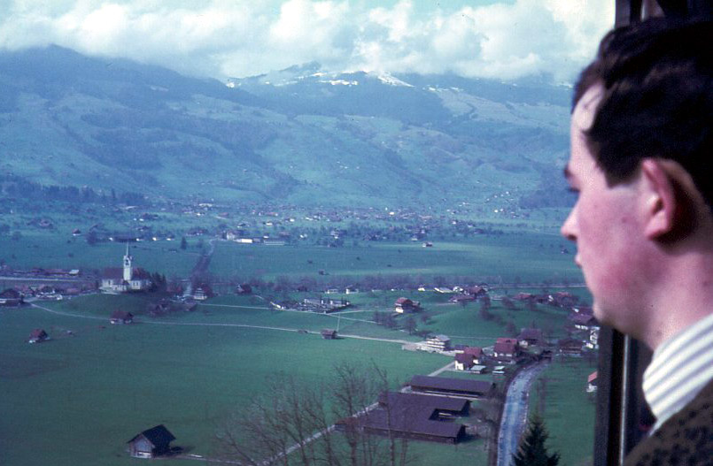

**Bev Lane, Lyn Thomas and Clive Ham on the slopes.**

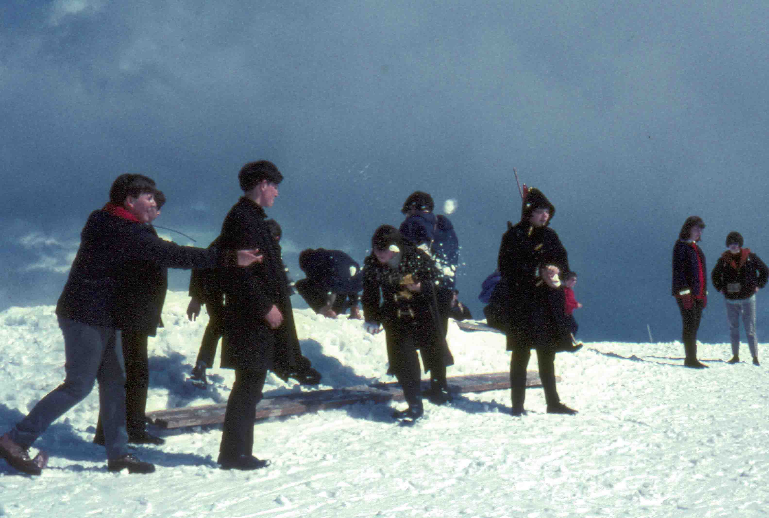

**Gary Berryman, Bev Lane and Lyn Thomas snowballing!**

**Bill Jones, who was at the school throughout the early '60's, remembers the field trip to Corsica, which took place in the March/April of 1967- he tells me that this is his only photograph of his time at Sexey's. Bill takes up the story.**

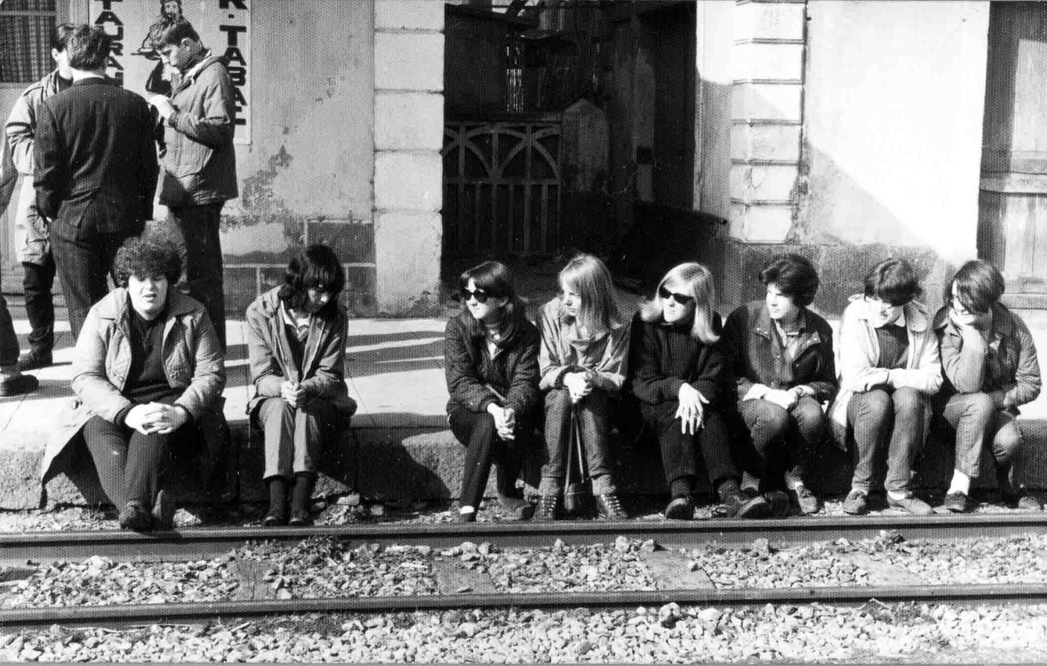

**'It was taken while waiting for a train at some godforsaken hole of a railway station, (a bit like Butch and Sundance arriving in Bolivia). The six girls on the right were upper sixth and the others lower sixth. Such is my memory for names and faces that the only one I can name is the blonde, second from the left of the upper sixth - I'm pretty sure this is Maggie James. I think the lad at the back is Paul Loveridge.' (It's actually Pete Roper, Bill - can *you* name the rest? - MJ)**

**'We had travelled down through France to Nice, then got a ferry over to Corsica. When we got there, the female teacher and one of the upper sixth girls, who I can't remember, disappeared off with two lads they'd met earlier. We didn't see them again until we got back on the ferry. That left Mr Breeze in charge of a predominantly female party on his own, which must have given him a headache or two! ' (I bet he loved it, really!- MJ)**

**'Anyway, we travelled around the island on public transport stopping at various camp sites. Corsica in those days was still a bit backward - we woke one morning to find the local women doing their washing on the rocks, in the river we were camping by!'**

**'On the way home we stopped in Paris for the night. I remember spending the evening in a local bar and all the students wanting to call it a night by 1am, ( Lightweights!! - MJ) but not the teachers. We were there for another hour and a half !'**

**( Virtually everyone would have had a camera on this trip, so I'll patiently wait for more pics to come in ...! MJ)**

**I need wait no longer, Peter Roper has given me a number of photos that he took at the time!**

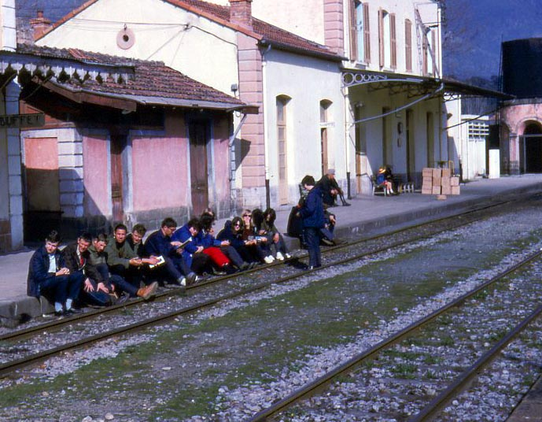

**The first picture shows the station again and includes the male contingent.**

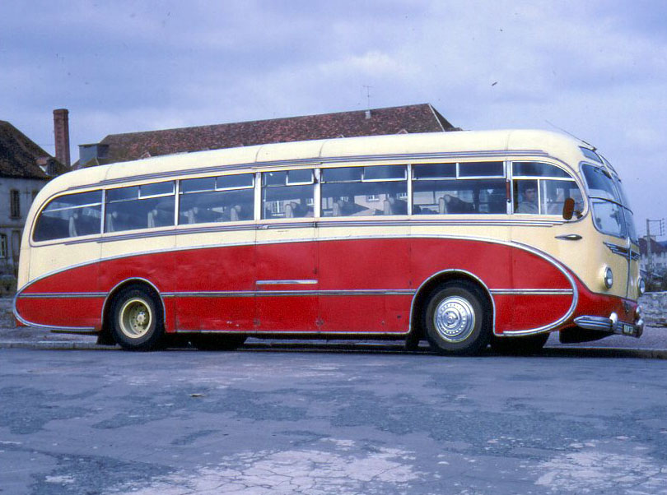

**Being a lover of classic vehicles, I couldn't resist putting this one in - this is the coach that took them round - what a beauty!**

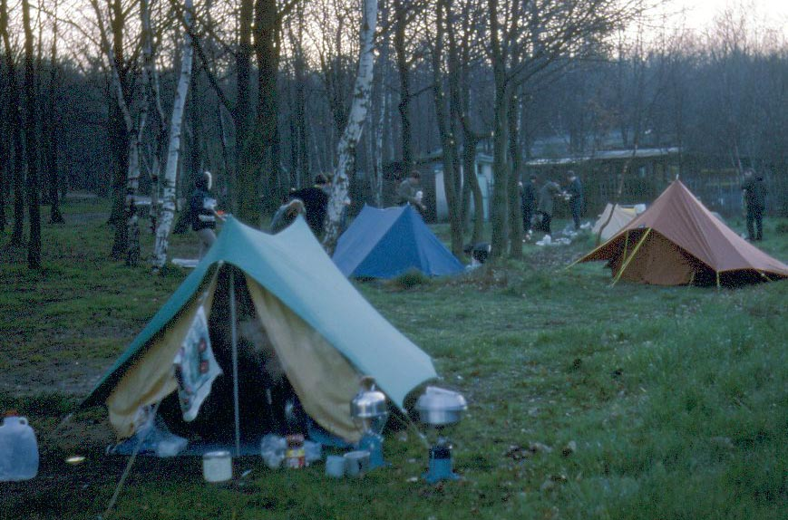

**No 5 star hotels on *this* trip!**

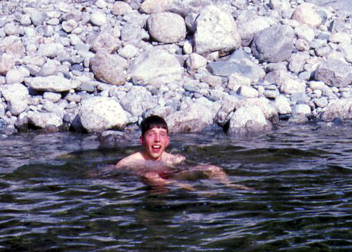

**A mountain stream acted as a handy bath - don't drop the soap, Pete!**

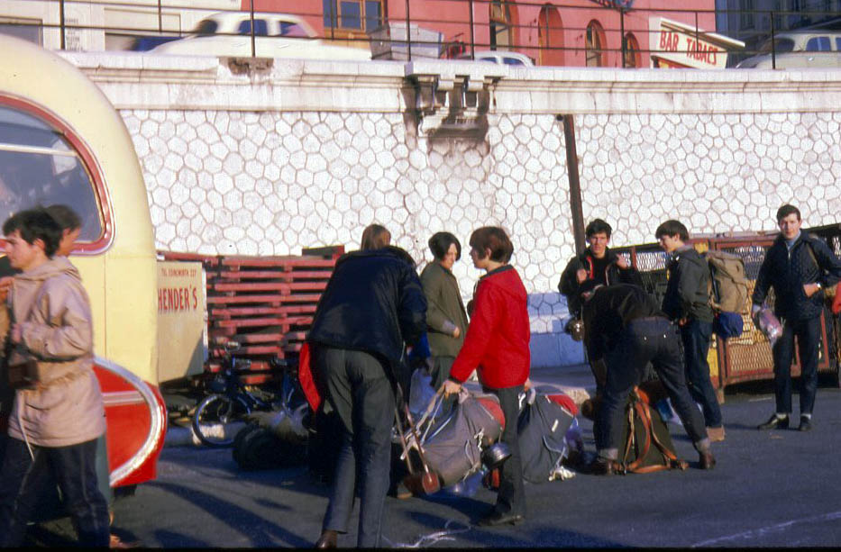

**Getting on the coach or getting off, I wonder?**

**In 1965 the school put on a production of 'Trial by Jury'. the school had originally put on the production in 1954 which would have been on the makeshift stage in the Dining room.  (As you can see i've got no information whatsoever to go with these pictures so if you can remember anything about this production please email me the details - MJ)**

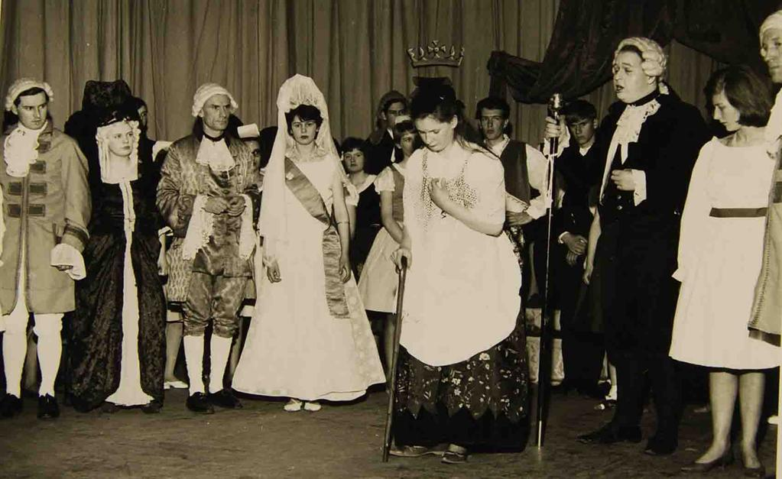

L-R  Mr Gordon Churchyard, ?, Mr Glynn Moore, ?,?, Bob Ford, Peter Gregory, Graham Badman (holding staff), Jennifer Belcher, Mr Peter Lee.

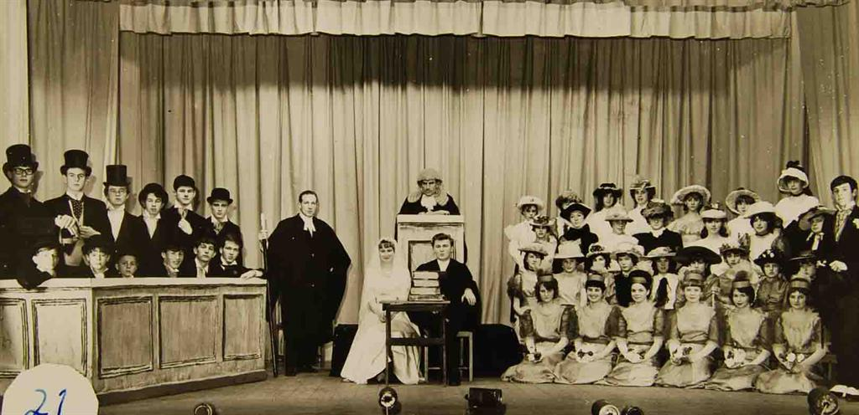

Centre Group - Mr Peter Lee, Mr Glynn Moore. Sitting ?, Ian Hart.(see final pic in this group).

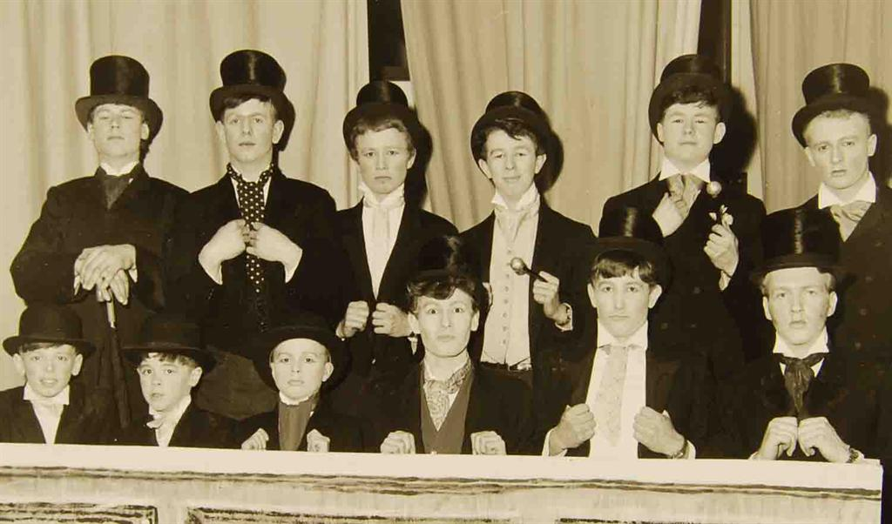

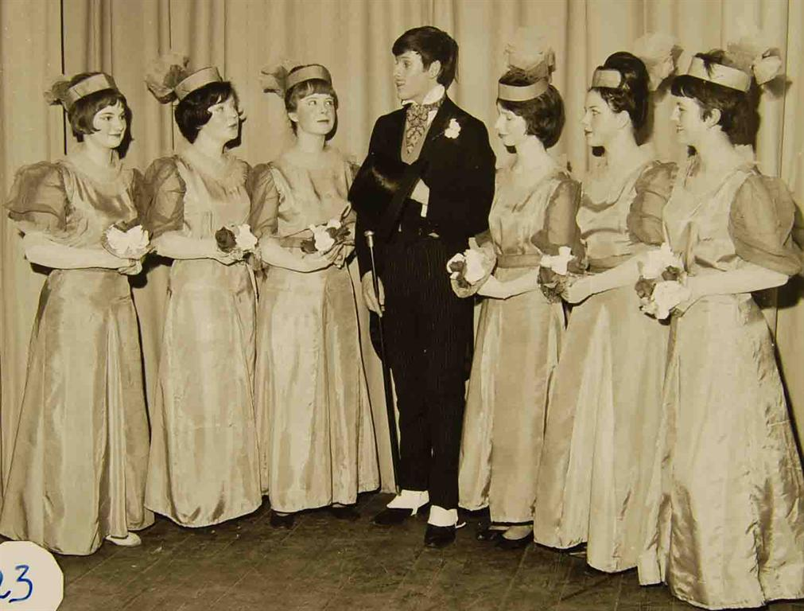

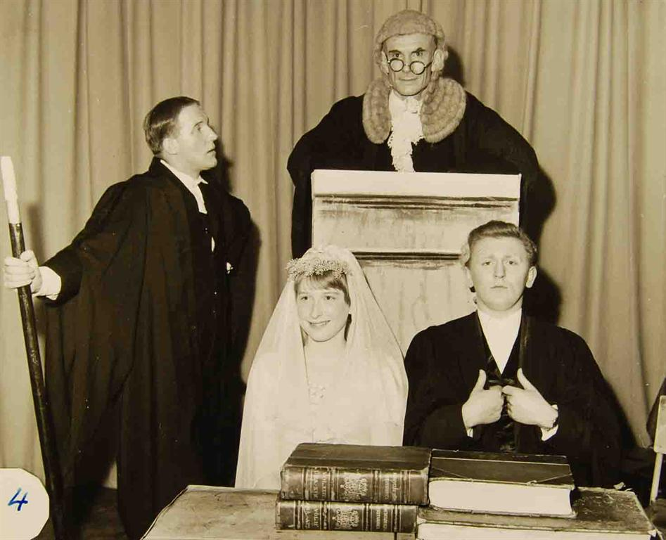

**Christine Hoskins (Derrick) joined the school as a pupil, in 1966, following in her grandmother's footsteps some fifty five tears later. Christine's article is the very first article contributed for the second phase of the website - many thanks, Christine!**

**Here are Christine's memories in her own words -   
   
'My period of time was 1966 to 1973. My worst subject was domestic science (odd for a girl) and I encountered Mrs Valda Ryder and her predecessor, Mrs Coles; neither of whom were ever greatly impressed by my efforts (which isn't greatly surprising). I also struggled with Maths, but Fred Roberts would never write a bad word in my report, despite my getting very low marks.**

**'However, I got my O level, and many years later I bumped into him near Congresbury; at which point I was able to tell him that I had also gone on to do maths at HNC level; which he was clearly pleased about and said that it was always good to know that the struggles had paid off!'**

**'Mr Dunn taught biology to the lower years, and I think also physics. Many boys were called "look, sonny" when they were being told off.'**

**'In the later years, like many people, I detested dissection work and struggling to cope with the formalin stench from preserved dogfish. A treble Zoology period in the afternoons was sometimes worse than a jail sentence, compounded by the strain of trying to keep up with Mr Brooke's handwriting. He, however, was easily outdone by Mr Elvins (History) whose writing was so tiny you were forced to sit at the front of the class to copy it off the blackboard.'  
   
'In Chemistry, many unofficial experiments were performed with aluminium powder, splints, bunsens and assorted biros on the back benches. These were often more interesting than the set project and Gordon Churchyard had his work cut out to ensure that no serious accidents happened.'**

**'Numerous holes were burned in jumpers, exercise books and even brief cases as the result of stray drops of nitric, sulphuric or other bench acids. Today's Health and Safety 'experts' would have quaked in their boots, well, not really, but it was a lot of fun!'**

**'French, in the first form, was taught by a Mrs Dykoff (and I'm afraid that's where my spelling fails me because I can't actually remember HOW it was spelt!). Later on, the class was with Mr Packer, and there was always another Monsieur or Madmoiselle on the staff, over from France, for most of the year.'**

**Mr Moore was my Latin teacher throughout, and I think immensely gifted to teach what could be a dry, dusty topic in such a way as to bring it alive with humour and stories.'**

**'Miss Rendell covered our English and RI lessons; I can recall only a few spells with Miss Padfield, she was never a "main" teacher for me.'**

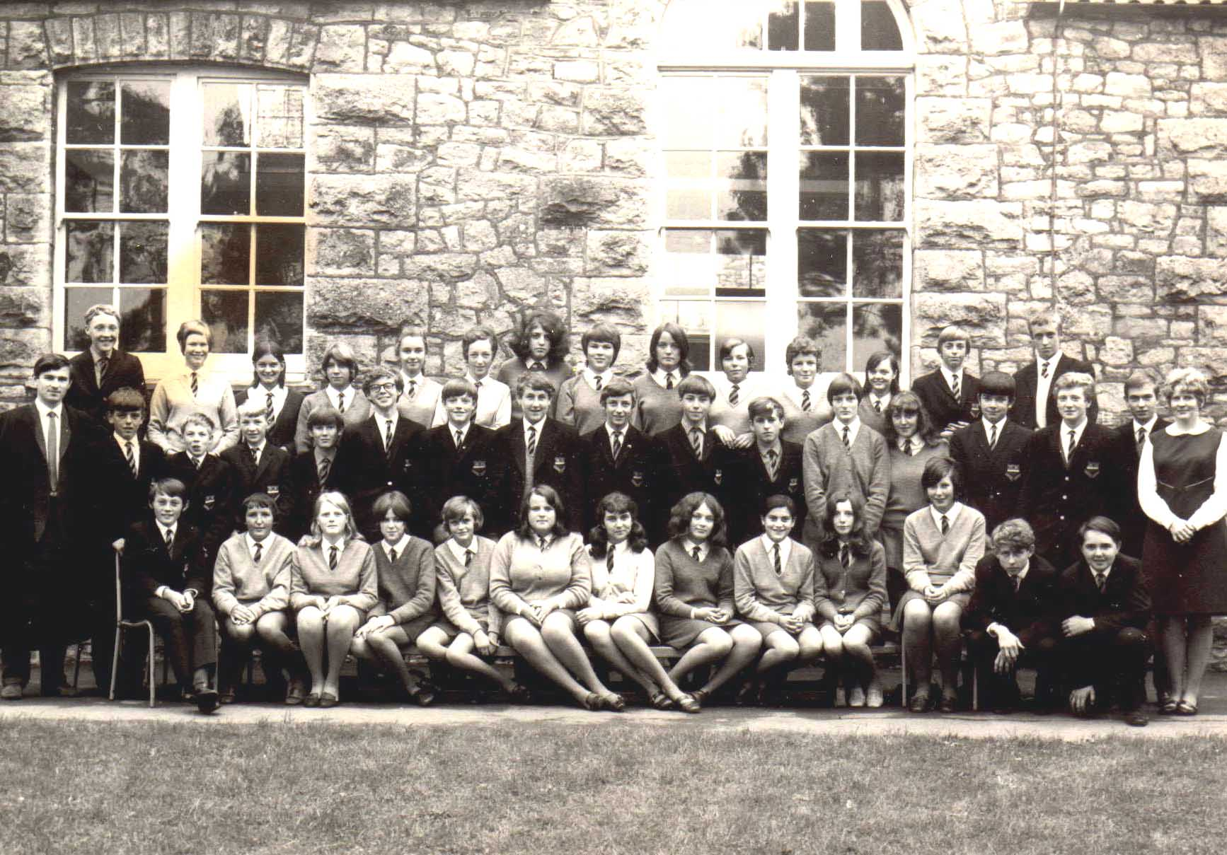

**Here, Christine can be seen with the rest of her classmates - the photo was taken in 1969.  
Back Row (L-R) John Banwell, Angie Webber, Susan Line, Rachel Frost, Karen Bloodworth, Dierdre Thomas, Linda 'Lofty' Shaw, Cordelia Welch, Josie Fear, Sally Manfield, Alison Tinknell, Christine Hoskins, Tony Stacey, David Adams. Middle Row (L-R) Mr Gordon Churchyard, Eric Puddy, John Reeves, David Banwell, Andy Ratcliffe, Tim James (Donald), David Olive, Michael Garbett, Trev Poole, Mike Thomas, Tim Shipsey, Erica Vowles, Ann Western, Michael Nicholson, David Plumley, Martin Howell 'Fred the Foot', and Miss ? Front Row (L-R) Tony Limb, Lynne Heal, Sue Barratt, Janice Lukins, Jill Steer, Karen Watts, Sharon Reaney, Pam Champney, Liz Johnson, Margaret Taylor, Jimmy Fisher and Steve Westby.**

**(Photo contributed by Christine Hoskins - many thanks to Sally Manfield (Adams) for filling in all the ?'s.)**

**'As far as sport was concerned, this was an area I had no particular interest in. However, Beryl Leach managed to somehow manipulate me into the swimming teams and the occasional athletics event, covering backstroke and either long jump or 800 metres. I think it was revenge for the fact that I was not very good at geography in her classes. I also survived a few of the cross country events, managing a 10th place on one occasion.'**

**'I believe Sexey's swimming pool had to have the coldest temperature recorded anywhere on Earth (I agree! - MJ), even a penguin would have  turned its beak up at the cold, sullen surface. Swimming was done even on cold, wet, misty days; pupils would traipse miserably out from the changing rooms, wrapped in towels and say prayers before entering the water.... you could hear folk saying 'Oh God' as they arrived. However, it provided plenty of house competition each year, and for some reason Somerville seemed to always have the better swimmers (but we 'Blakes' would always get even on the running track).**

**'Away from lessons and sport, other events included a 'general election', where a small group of people stood as candidates for Labour, Conservatives, and other less well-defined political movements. They would spend a number of break and lunch times delivering speeches, then a voting day would be set and everyone cast votes in cardboard ballot-boxes. I do not recall the outcomes of these events, nor indeed whether there was more than one; but it was quite an unusual few weeks.'**

**'Elsewhere on the website, the school magazine has been mentioned, and I think this caused a bit of a stir when it was first announced. Everyone was encouraged to contribute something. I still have a copy somewhere at home. Stories, reports, poetry and similar were all offered up; one that sticks in my mind even now is a short piece by Vince Russett, that started off as 'The mushroom! it grows and grows....' with reference to Nagasaki, I believe. Funny how tiny snippets remain in memory and larger events elude us entirely.'**

**'There is one particular period that I wish had been possible to extend;in my time in the 1st form I can remember a woodwork teacher (Mr Atkins?- MJ) who used to hold simple woodwork classes during a lunchtime, for anyone to attend. This, to me, was more interesting than cooking buns or sewing aprons, and I really enjoyed sawing wood and making small items, including a pendant and a fruit bowl. However, he left at the end of my first or second year, and no more classes were ever done (that I know of).'**

**'I also had to give up Art after the third year, because of the way the subject-choices fell for the O level studies. This was another period of happy creativity. Mrs Peak was teaching at the time and after she left there was a Miss or Mrs Elliott.' ( Many thanks for your contribution, Christine. - MJ).**

**In 1966, the school put on a performance of 'A Midsummer Night's Dream'. Including the helpers behind the scenes, this involved about a quarter of the school's pupils. Press reports at the time were very favourable -**

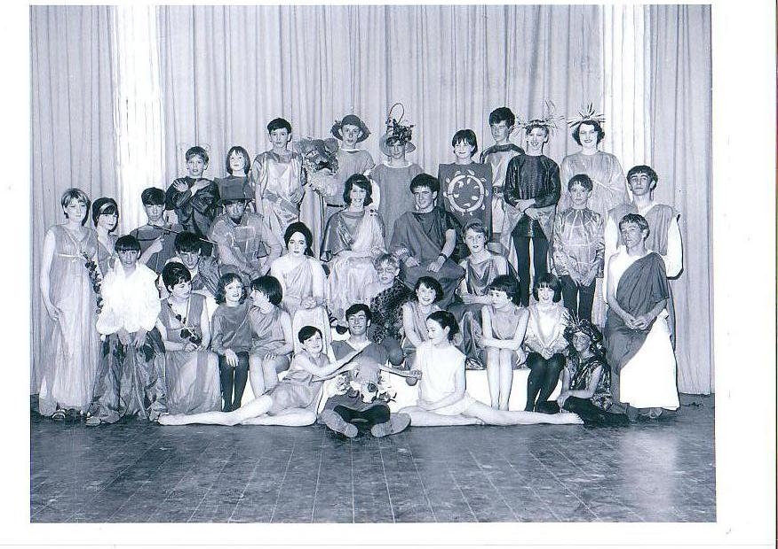

**The 'Burnham Gazette' of 2/4/66 said it was 'extremely well acted.' The 'Weston Mercury ' was also full of praise. *Both* newspapers agreed that Alan Vaughan (Bottom) and Steve Thorne (Peter Quince) gave exceptional performances. Here is Clive Toomer's article from the Weston Mercury -**

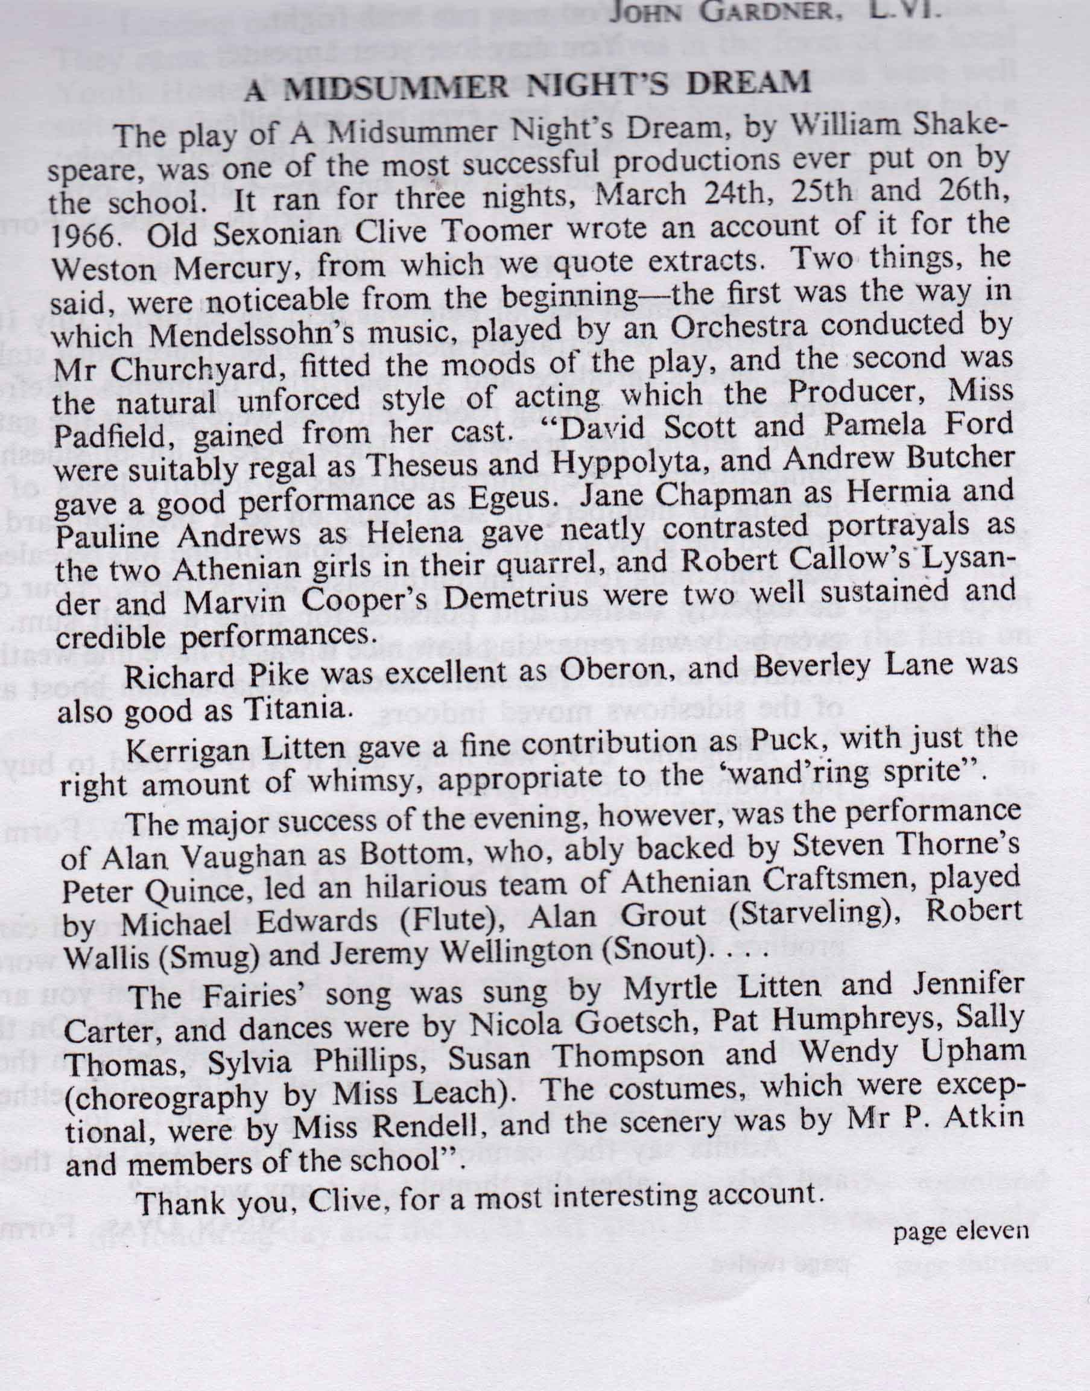 (Thanks to John Grant)

**The following year in 1967 the school put on a production of 'The Mikado'. The following picture of the programme show some of the main cast members -**

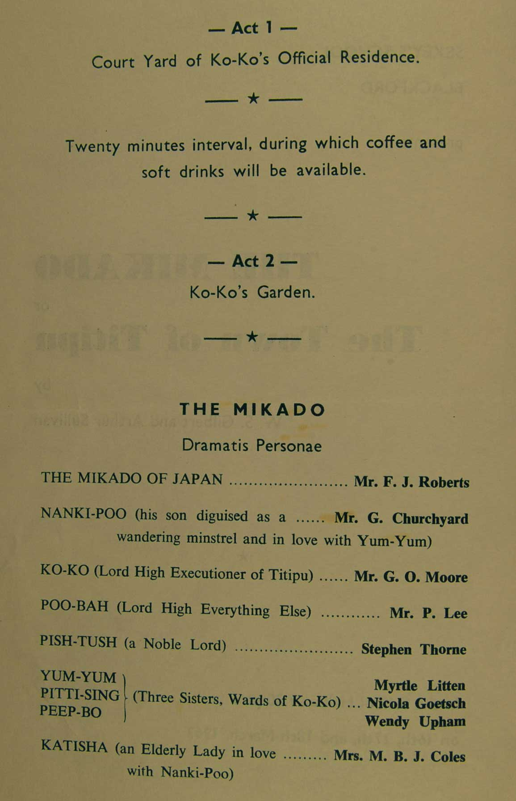

**The male and female cast members. A colour version of the male cast can be seen in Gallery 4.**

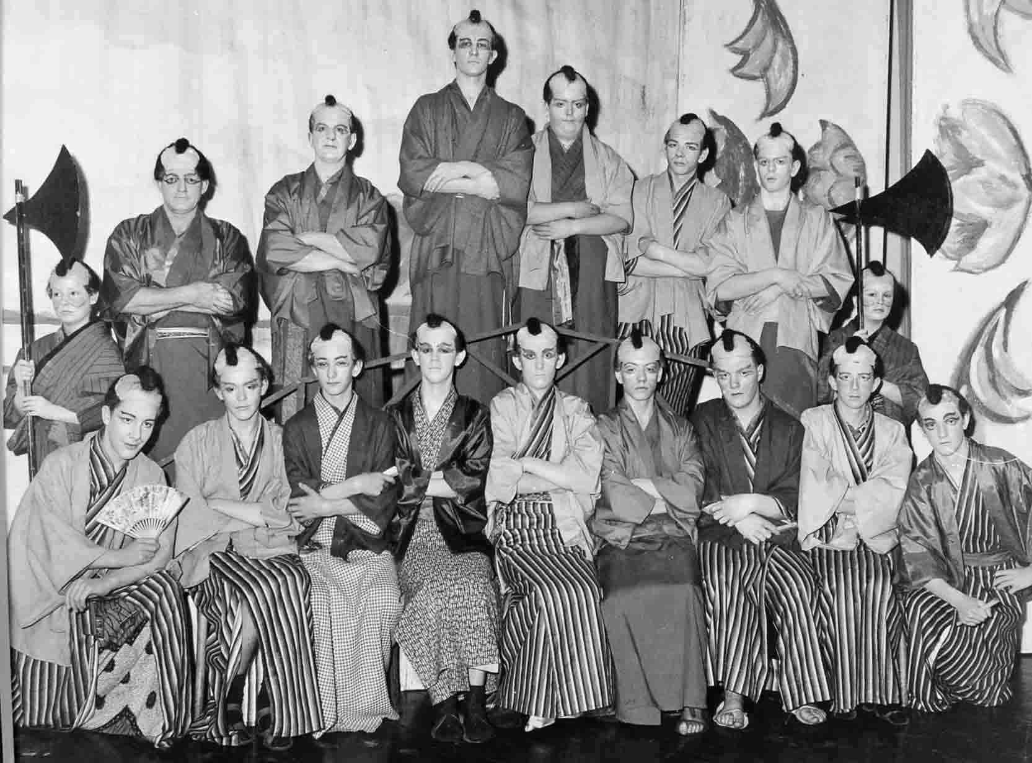

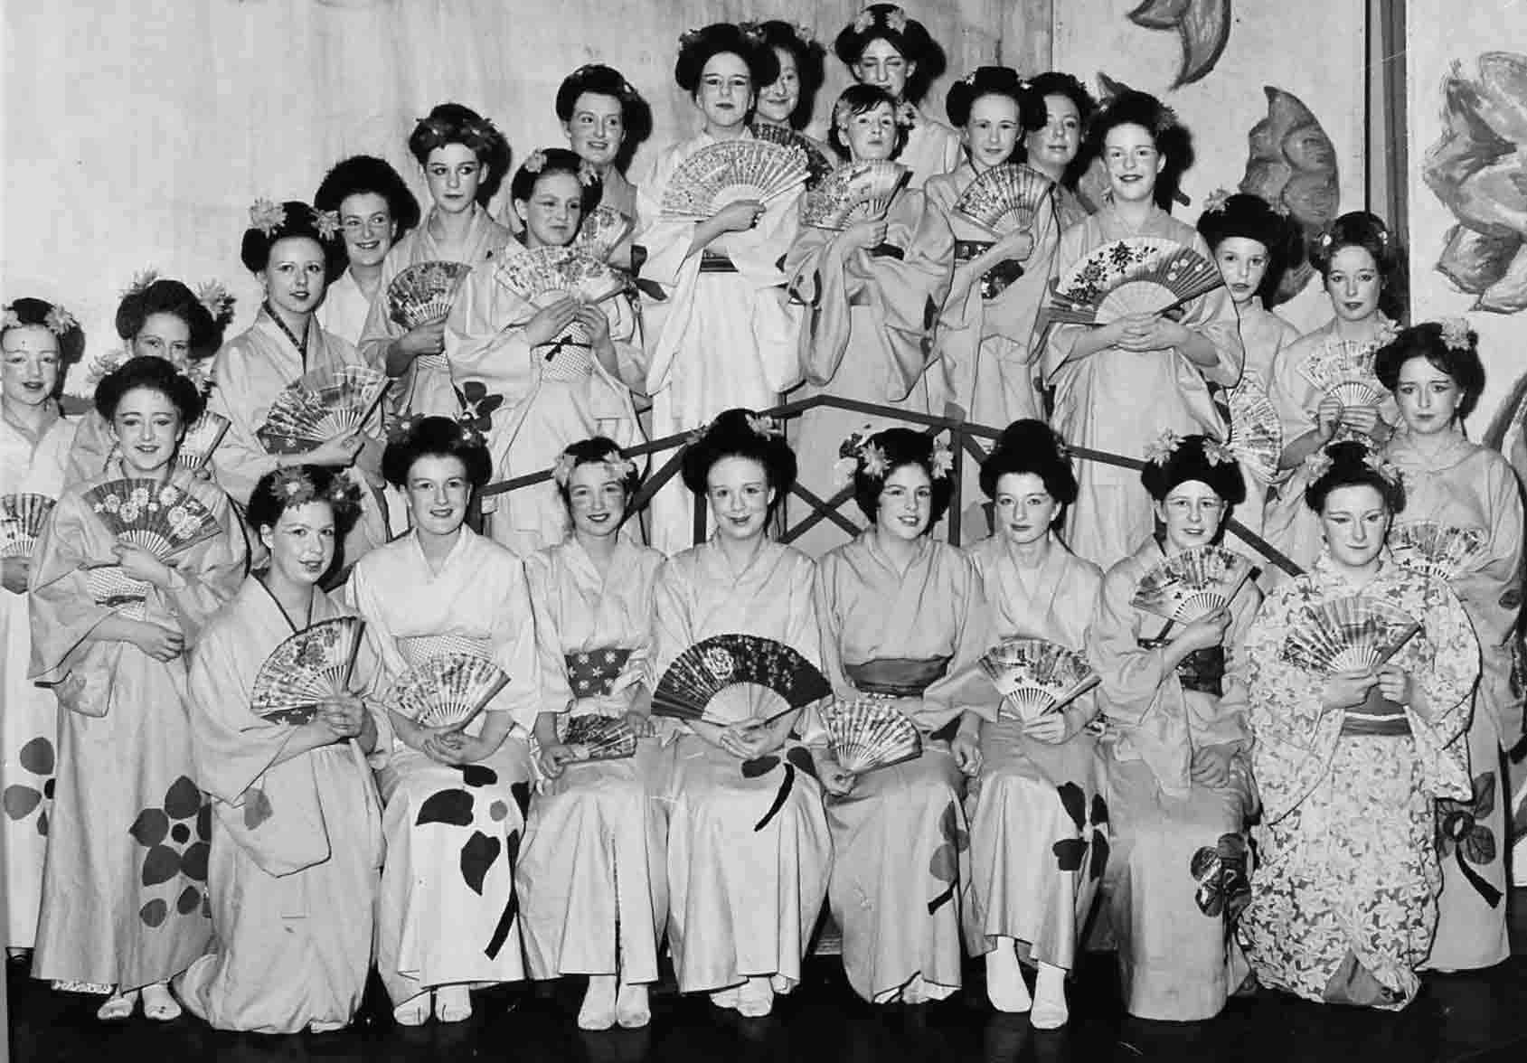

**(Anyone with any memories/names from this production please send them in.)**

**In 1967 Andrew Turner joined the school as a pupil, here are some of Andrew's memories - 'I left on July 3rd 1972 (5th form). We were only 4 from St. Andrew´s junior school in Burnham-on-Sea (Martin Holmes, Susan Litton and Jane Small) who received a place at Sexey´s - an "embarrassing" name to have to write down on employment application forms abroad in later years !.'**

**'We were all in Beryl Leach´s 1st form whom I disliked! She addressed all the boys by surname only, like an army commandant! I did miserably in her geography lessons ( 1st & 3rd form), but very well in Miss Smith´s, who made the lessons interesting by showing slides concerning the countries she was teaching about.'**

**'I just read Isabel Rendell died last year at 105 - I was surprised she lived so long, she was one of my favorites and retired also in 1972. I visited my old class in 1973 and acquired some French grammar A4 sheets from Mrs Chew, which helped me tremendously to teach myself German (now almost my mother tongue) and Italian, by following her method.'  
  
'After 4 years of working for the Nat. West Bank and Brooke Bond Oxo-Bristol (computer payroll clerk), I travelled and worked in Canada 1n 1976 / 77 hitching to Alaska and through the deserts to L.A. In 1978 I hitched through Europe to Algeria and across the Sahara Desert. I then "ended up" in Munich for 3 years, Milan 3 years, Switzerland 1 year, Hamburg 15 years from 1985, but already comuting to West Berlin from 1988 - 2002 through the GDR (DDR) 300 kms then finally remaining here ever since.'  
  
'On the 1971 photo showing some school boys skittling, it could be me on the right. On the almost complete school photo of 1969 ( my father paid 8 shillings for a copy that I still have framed on my wall), I am the first on the left, 2nd row, Christopher Phillips is next to me (internet cut-version).**(Many thanks for those memories, Andrew - MJ ).

**One of the local newspapers covered the 1968 Sports day results in some detail whilst making reference to the devastating floods in Blackford and the surrounding area - Somerville beat Blake that year. (Contributed by Jackie Skidmore).**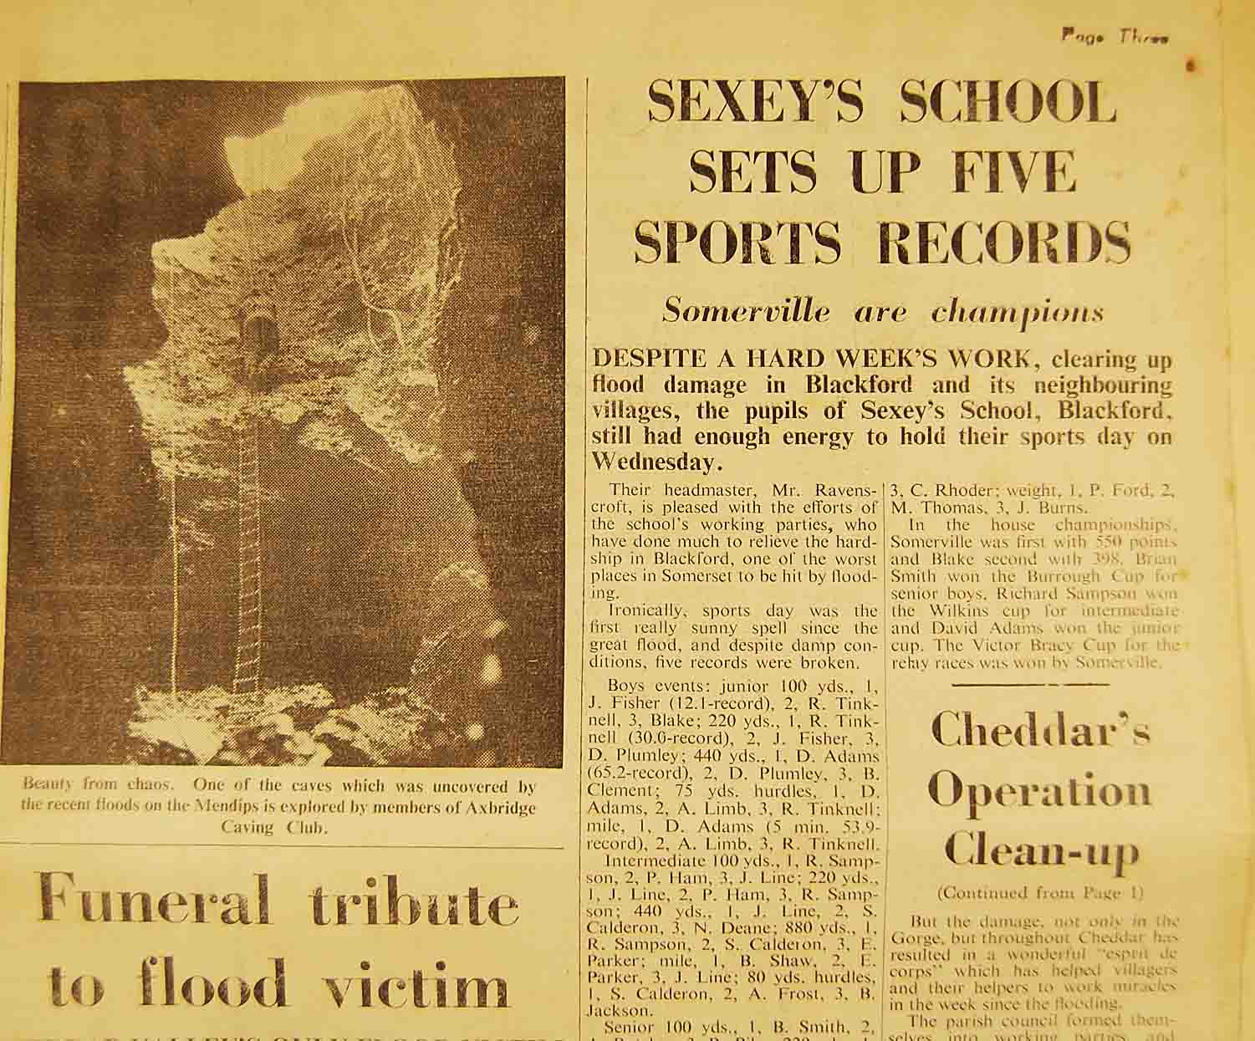

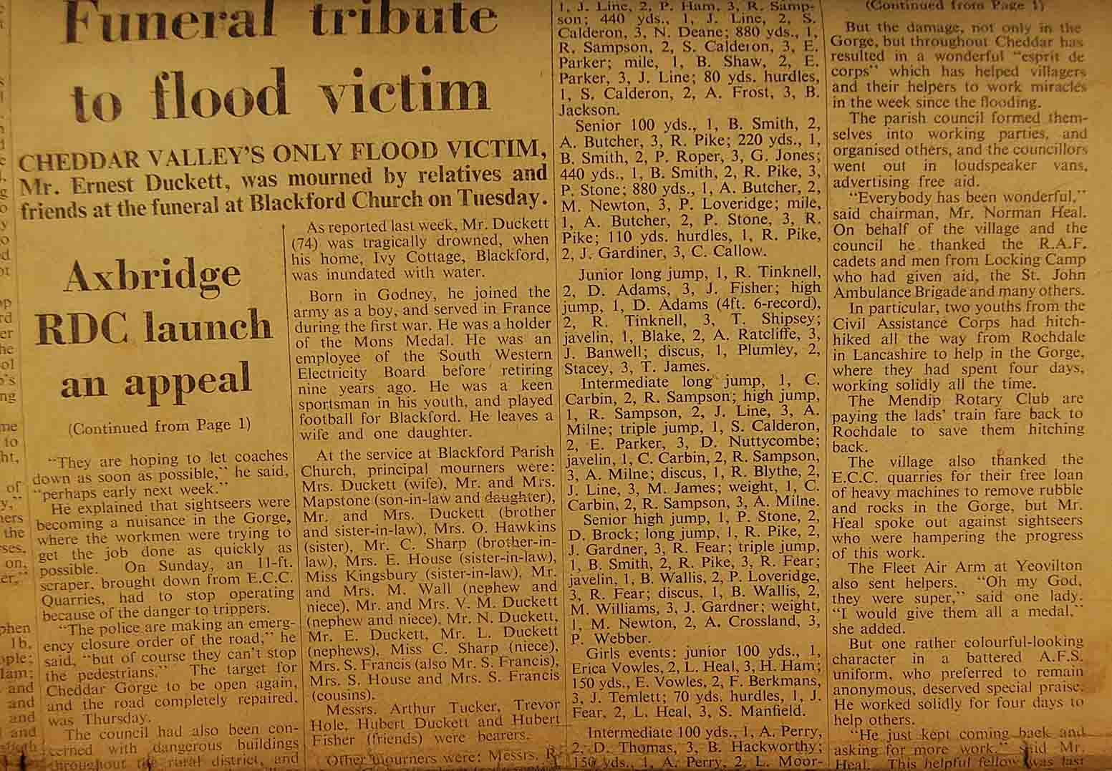 **The funeral of Earnest Ducket who was drowned in the Blackford flood was covered on the same page.**

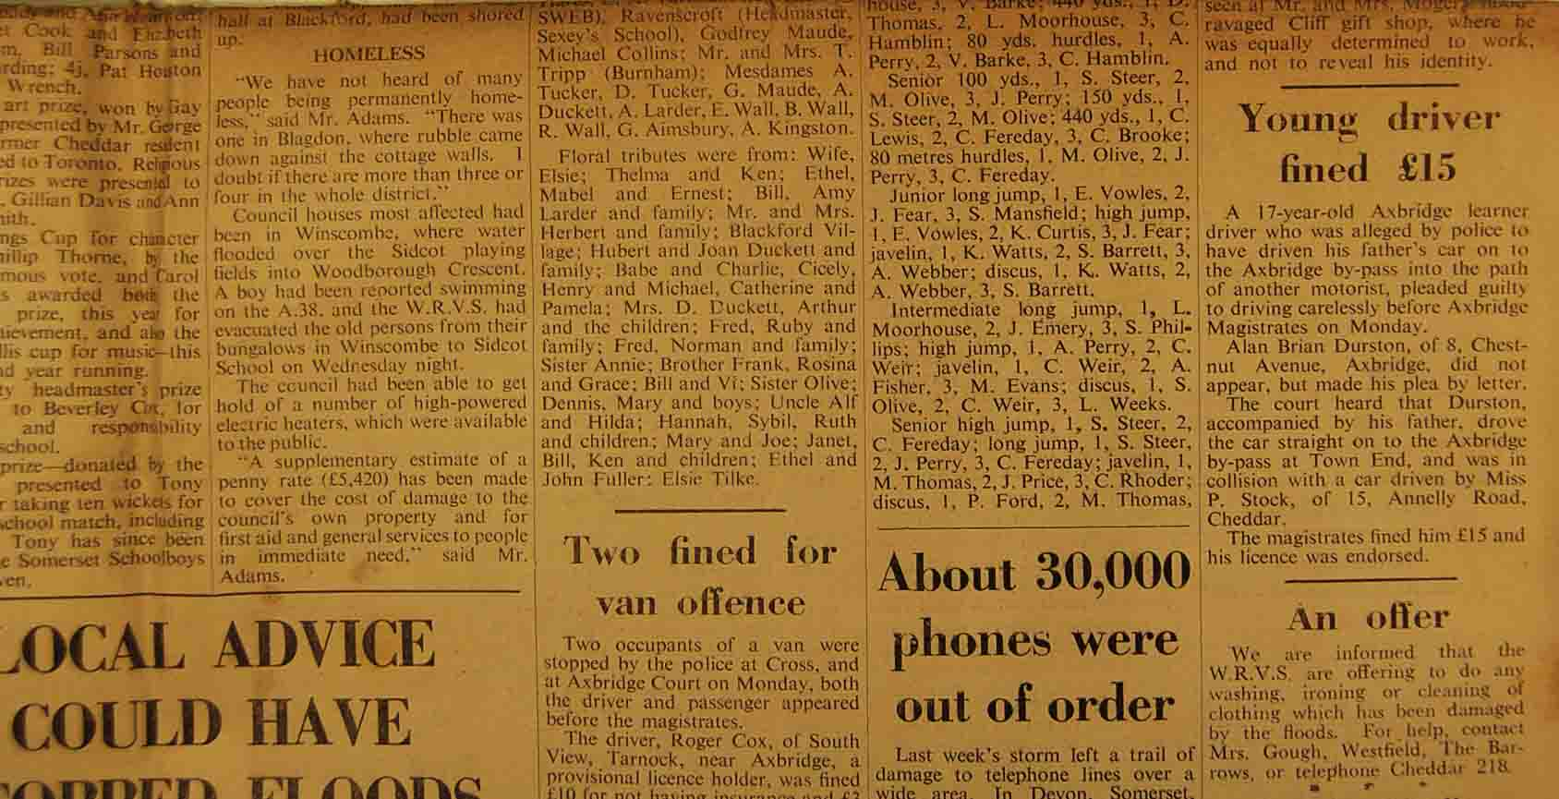

**It's nice to see so many pupil's names mentioned in the newspaper - memories jogged for a lot of us!!**

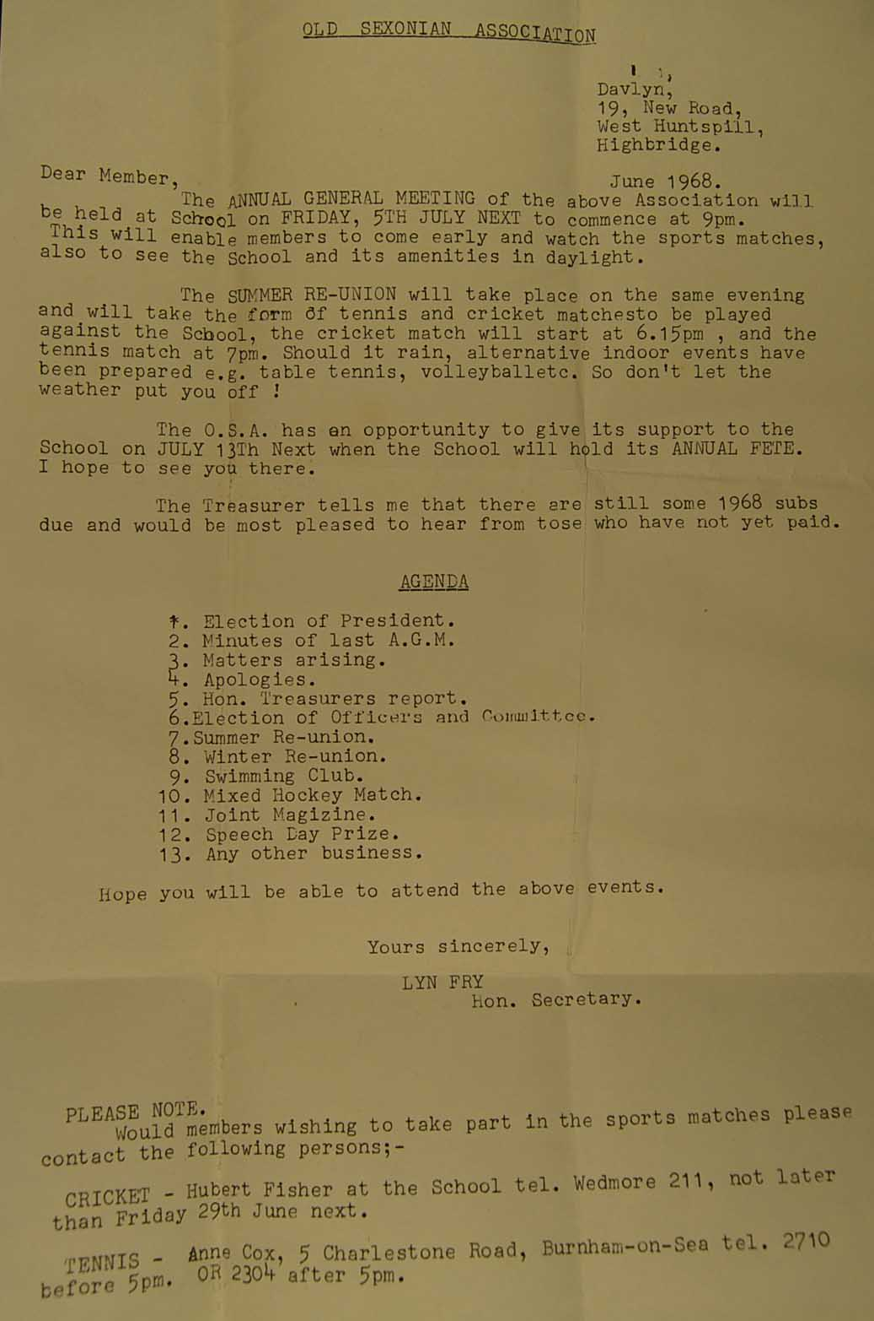

**This OSA letter fits in really nicely with the newspaper cuttings as it gives us the date of Friday, July 5th for the Sports Day - or were the Sports matches held on a different day?!?**

**The school's Speech days took place on an annual basis, as you would expect. Looking at the dates on several of the programmes, these were held on the second Friday in December**.

**In order to inform and gauge numbers for seating purposes, invitation cards were sent out to parents. (This one, from '68, was supplied by Tony and Lynda Cousins.) Despite the 'Friday 13th' date, I don't think there were any major mishaps!**

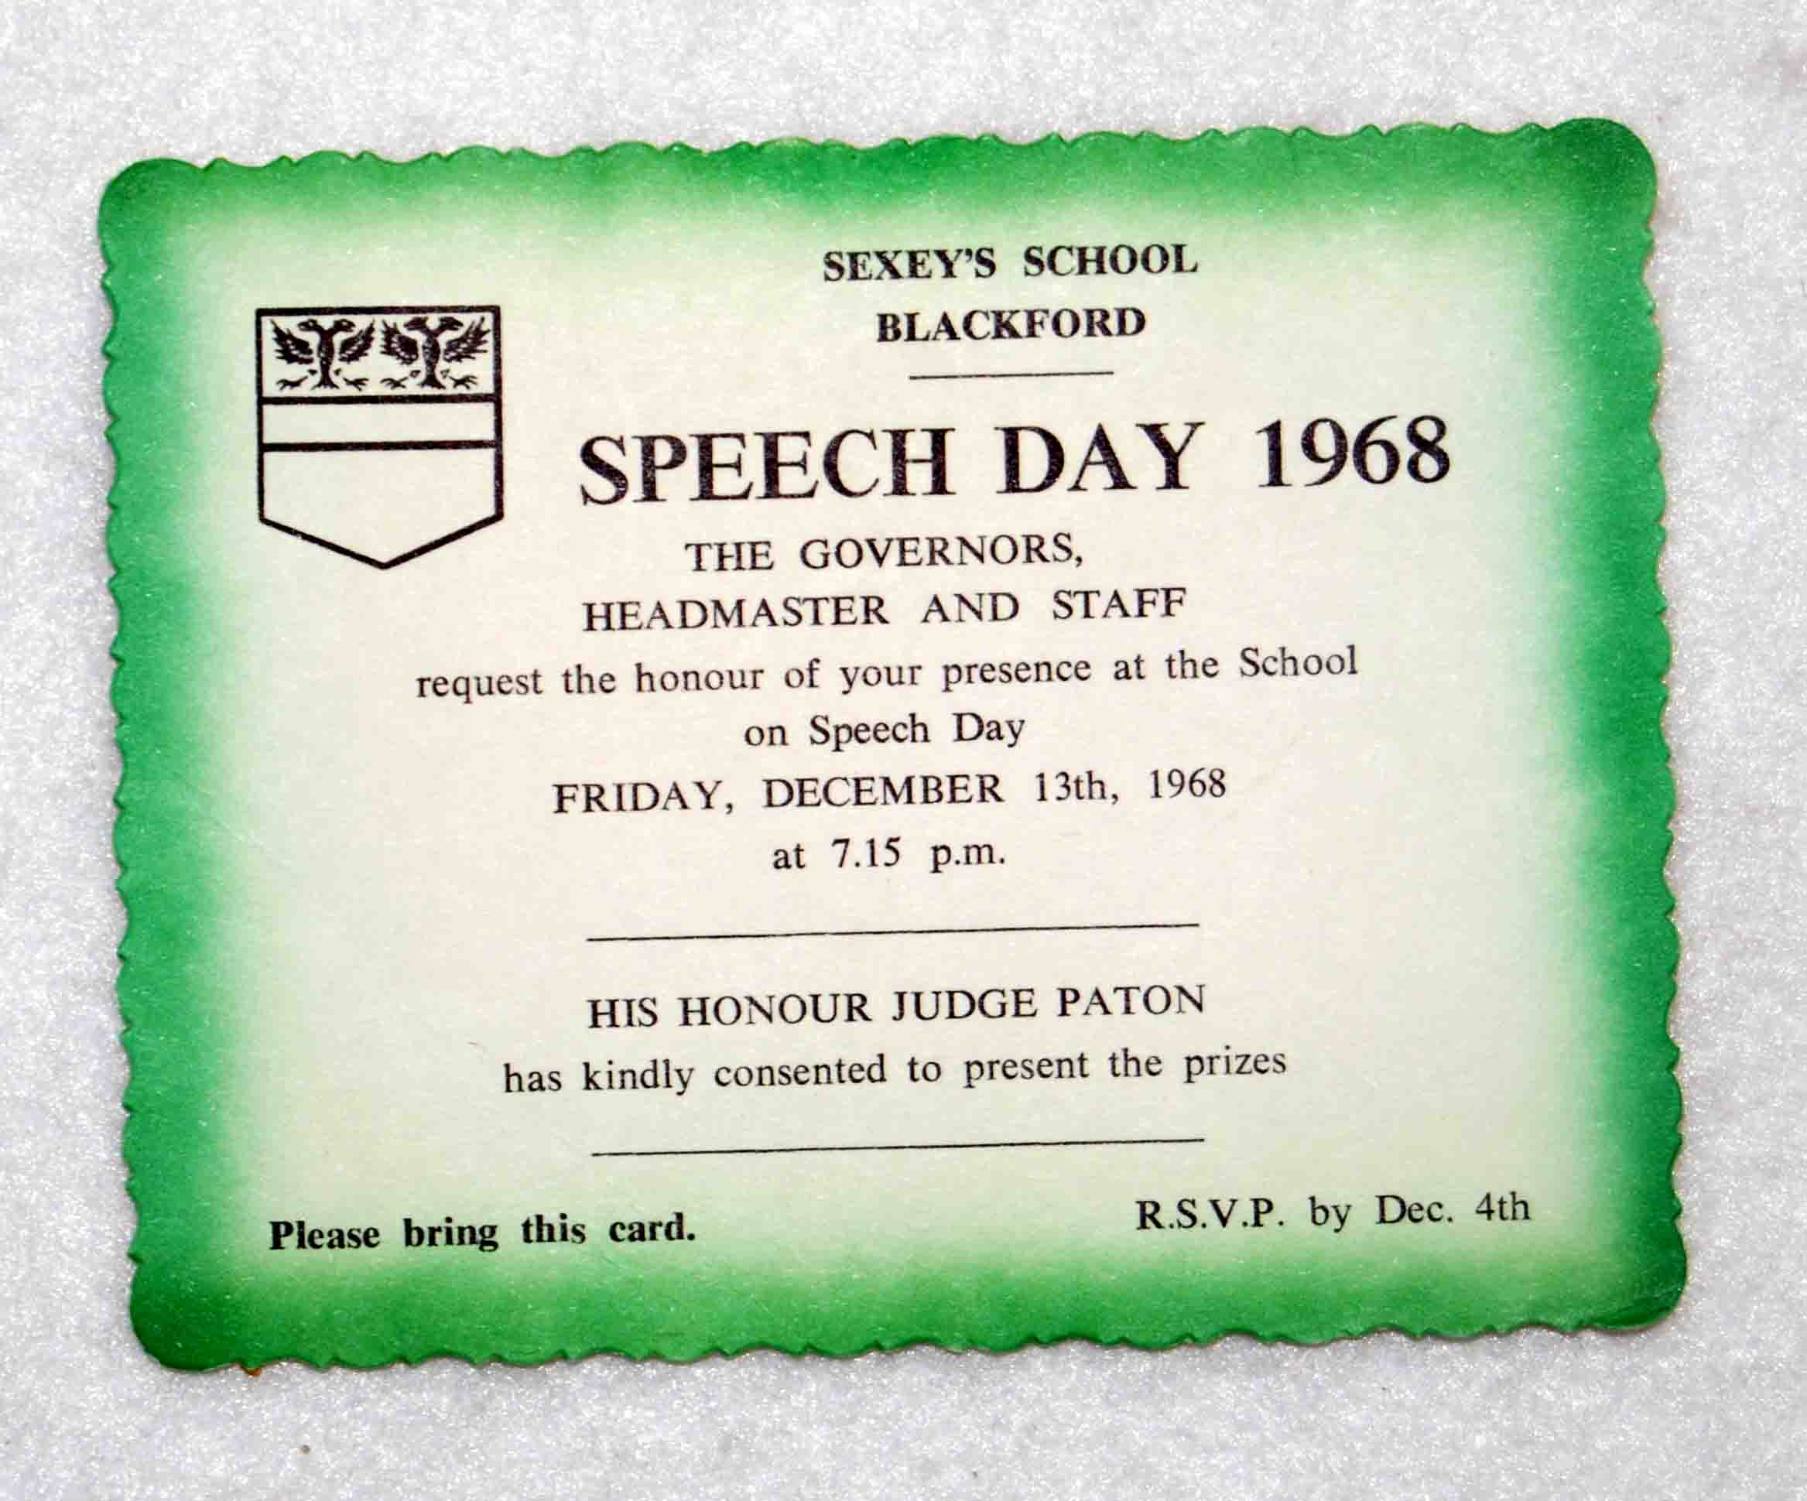

**The programme itself was a simple, four sided affair using folded, white card and black text - although it was professionally printed (by Shearn Brothers, Burnham on Sea, in 1968). This photo (from a press cutting) has been kindly sent in by ex pupil, Pete Nicholson.**

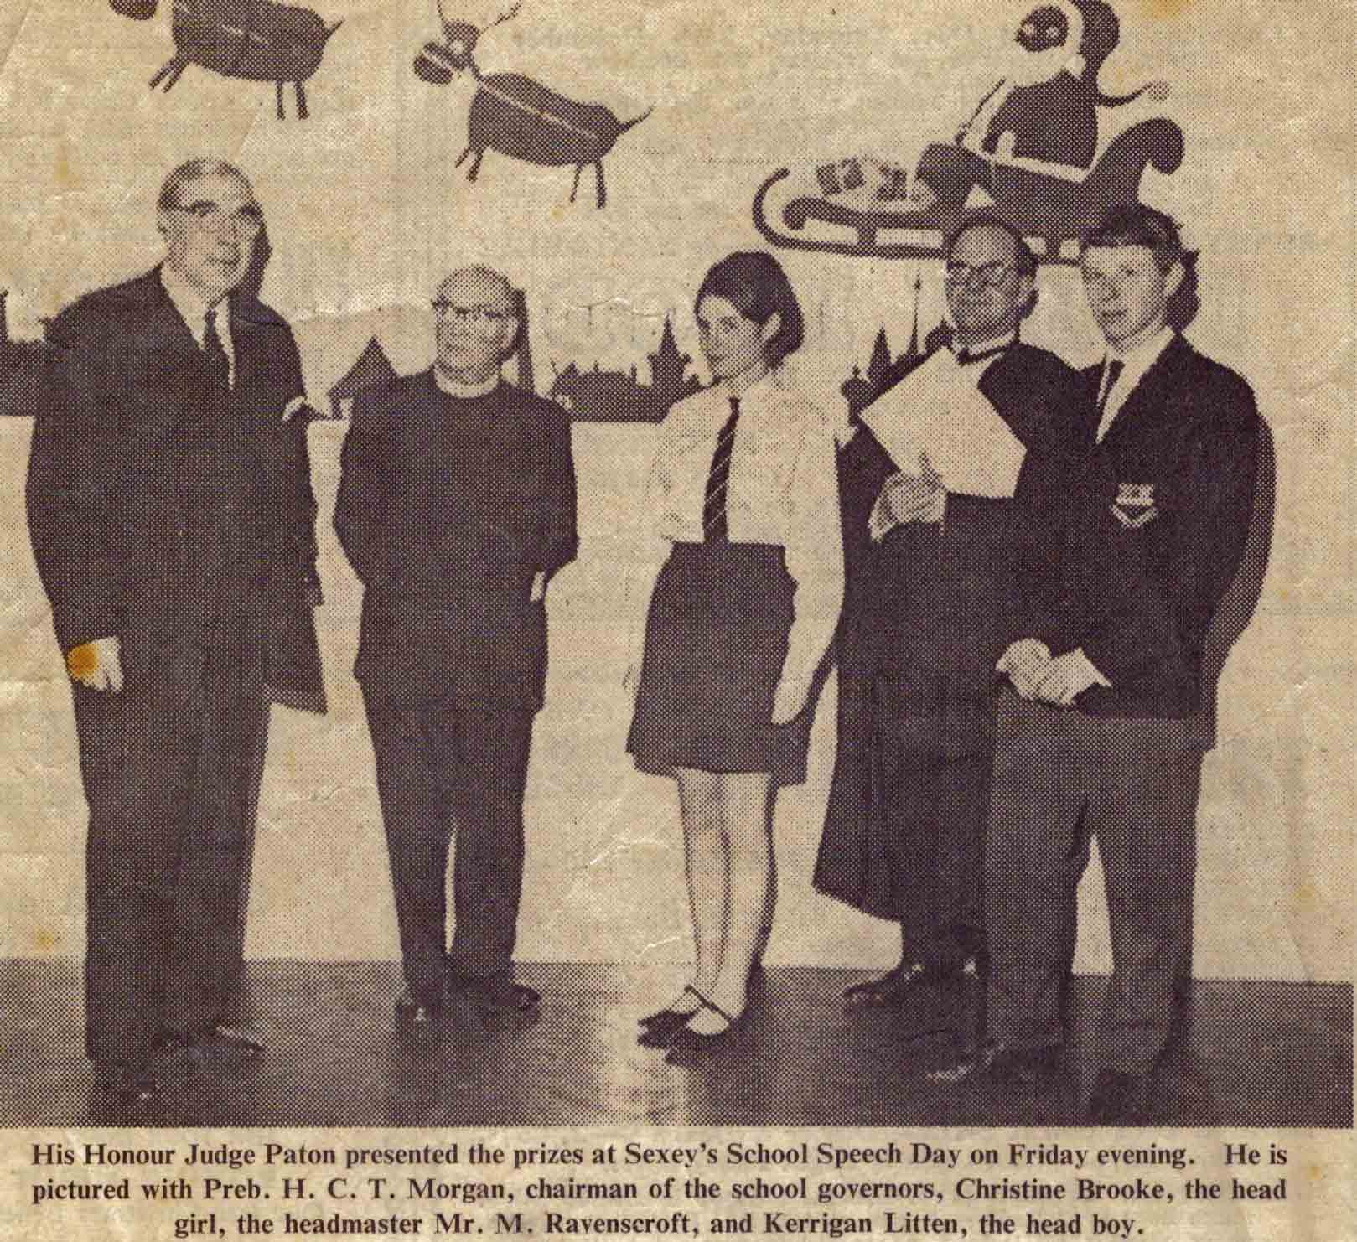

**An inspection of the 1968 programme reveals that Christine Brooke was the head girl and seconded the 'Vote of Thanks'. The 'brainboxes' at the time were Andrew Bradley who passed four 'A' levels and four other pupils (Margaret Bowerman, Christine Brooke, Kerrigan Litten and Paul Webber) who passed 'A' level mathematics a year early.**

**Of particular note amongst the 'O' level candidates were Pamela Callow, Barbara Cox and Jane Perry who each attained twelve passes.**

**According to the 1969 'Sexonian' magazine - 'The event concluded with some fine singing by the School Choir.**

**In 1968 the school had a large entry of pupils and the class of '68 was split into two, Class 2L and Class 2M - here is Class 2L two years after their arrival as class 4L (Kindly contributed by Louise Peace nee Calderon).**

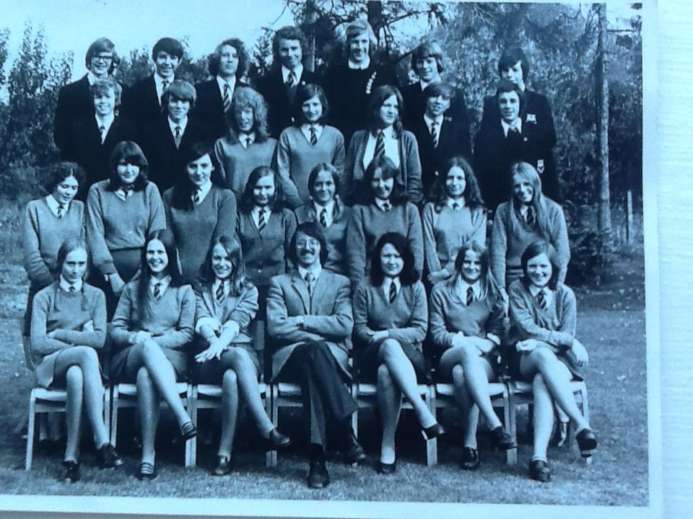

**Back Row (L-R): Ian Morse ~ Howard Pike ~Tom Day ~ Nigel Palmer ~ Alan Simpson ~ Andrew Perry ~ Andrew Williams.**

**3rd Row (L-R): Stephen Swan ~ Brian Miles ~ Sue Ham ~ Clare Wallis ~ Janet Ravenscroft ~ Jeff Savage ~ Paul Blake.**

**2nd Row (L-R): Denise Jones ~ Katie Smith ~ Suzanne Wilson ~ Vivienne Vining ~Fiona McGregor ~ Bev Timms ~ Jo Lillington ~ Linda Nuttycombe.**

**Front Row (L-R): Sabine Goetsch ~ Nicky Day ~ Jackie Cox ~ Dr. Steve Chinn ~ Louise Calderon ~Vivika Alexander ~ Sue Easton.**

**This picture was kindly sent to me by Sally Adams and is the final, whole school picture of  the  1960's, taken in 1969. This is the central section and shows the majority of the teaching staff.**

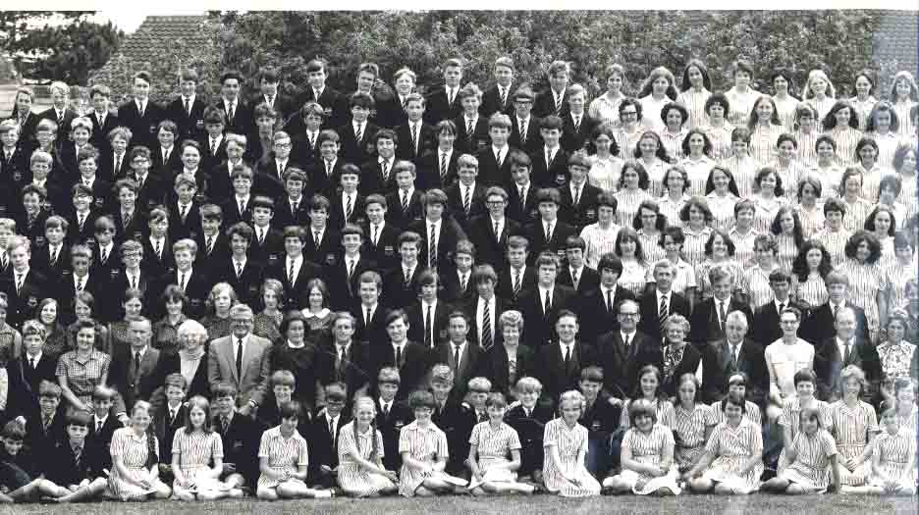

[**Back to the Top**](http://www.oldsexonians.com/page7.htm#top)

**If *you*have *any* memories/anecdotes/pictures from this era, whether they're 1st, 2nd or 3rd hand, please send them in to**

[**oldsexonians@hotmail.co.uk**](mailto:oldsexonians@hotmail.co.uk)